**Abstract**

Climate change is rapidly altering local temperature regimes and in different ways across the landscape. To cope with these rapid changes, plants species must have the capacity to respond to changes in temperature stress or risk extinction. In this study, we compared temperature tolerance traits in *Solanum carolinense* populations from Texas, USA and Minnesota, USA to understand how a species adapts or acclimates to extreme temperature stress. We included traits affected by temperature in both the gametophytic and sporophytic stages to inquire about independent means of selection. We found that mechanisms in temperature tolerance differ between populations of the south that face extreme heat regularly and northern populations that do not. We found evidence that southern plants induced heat tolerance with exposure to rising temperatures in the sporophyte and produced a higher proportion of pollen that remain dormant in unfavorable conditions. We also found a correlation between temperature tolerance in the gametophytic and sporophytic stages in southern plants, but not northern plants.

**Introduction**

Climate change is rapidly altering environmental conditions at the local level and in particular, temperature and precipitation regimes and the severity of weather events. How will plants, a mostly sessile taxa, cope with these rapid changes? Given the rapid change in local conditions, there are three ways plants can respond while avoiding extinction; quickly adapt, tolerate changing conditions through plasticity in phenotype that allows acclimation to the new conditions, or shift ranges. We conducted a study that focuses on the variation within populations and addresses the potential for the first two of these options in a widespread, weedy species.

The conditions across a species range are potentially heterogeneous and can have a variety of selective pressures that act on the populations differently. Divergent selection in two different locations can result in differing trait optima in separate populations, leading to local adaptation (Kawecki & Ebert, 2004). How a species adapts or acclimates to separate locations provides a clue to how a species in one location might respond as global warming changes local conditions. Temperature is a prominent variable that can determine species distributions and can vary greatly in both severity and consistency with geographic region. There have been many adaptations in different species that improve survival in extreme temperatures, but how do populations of the same species persist in different temperature regimes? To understand local adaptation to diverging temperature regimes, we must understand the biology of plants under different temperature regimes and how they are vulnerable to extreme temperatures.

Temperature can impact plant physiology and cell structure in a few ways. Temperature stress changes the fluidity of phospholipid bilayers. Heat increases fluidity and dissociation, while cold decreases lipid adhesion and increases rigidity. Both heat and cold stress results in cytoplasm leaking from the cell membrane. Plants that are more tolerant of temperature stress would have the capacity to maintain cell membrane fluidity and reduce cytoplasm leakage. High temperatures also affect photosynthesis via the decreased affinity of Rubisco (enzyme responsible for carbon fixation in photosynthesis) to CO2 and increase its affinity to O2 (Bauwe et al., 2010; Zhu et al., 2018). The fixation of O2 produces compounds that are needless and requires photorespiration to recycle components necessary for photosynthesis, in the process, reducing the efficiency of photosynthesis (Bauwe et al., 2010). In extreme temperatures, hot and cold, proteins and enzymes can be damaged or rendered inactive. This can have an immense effect on photosynthesis because the protein complexes in photosystem II and the electron transport chain can unfold (Zhu et al., 2018). The degradation of integral proteins and enzymes can also lead to the production of reactive oxygen species (ROS) through the excess absorption of light energy and prolonged excitation of chlorophyll molecules (Mishra et al., 2019; Wahid, 2007; Wahid et al., 2007). Chlorophyll excitation isn’t exclusively in the thylakoid membrane, where the light reaction typically takes place. Temperature stress can damage thylakoid membranes releasing chlorophyll. Chlorophyll will continue to absorb light energy even when free from the membrane. Excess energy from chlorophyll forms free radicals which are donated to oxygen molecules forming reactive oxygen species (ROS), which are highly reactive and damaging to cellular components. Therefore, plants typically degrade free chlorophyll or transform chlorophyll into alternative configurations quickly, reducing the chlorophyll fluorescence (Kariola et al., 2005). Plants that are capable of tolerating temperature stress would have less chlorophyll degradation. Oxidative stress due to ROS hinders physiological mechanisms such as photosynthesis, metabolism, and cellular structure directly or indirectly by reacting with metabolites or damaging macromolecules. Some of these cellular processes are not unique to diploid cells of the plants (sporophyte), but also occur in the haploid cells such as pollen and ovules (gametophyte). Extreme temperatures can limit pollen production, tube growth rate, and viability (Gajanayake et al., 2011; Kakani et al., 2002; Singh et al., 2008).

There is variation in the sensitivity to temperature stress and thus adaptations do lead to populations that are less sensitive. For example, cell membrane stability can be maintained in high or low temperature stress with the incorporation of fatty acids (Zhu et al., 2018) or sterols (Dufourc, 2008a, 2008b; Valitova et al., 2019). The production of heat shock proteins, a chaperone protein, also reduces temperature stress by preserving the shape of other proteins and enzymes required for normal function (Frank et al., 2009; Goswami et al., 2010; Knight & Ackerly, 2001; Lin et al., 2018; Liu et al., 2016; Nurminsky et al., 2018; Rhoads et al., 2005). For these adaptations to occur, temperature must be a selective pressure that influences the survival or reproduction of the species. In angiosperms, selection can act independently in the two life stages, the sporophyte (diploid; full plants, vegetation) and the gametophyte (haploid; ovules, pollen). It has been shown that there is a substantial overlap in genes and gene expression between the two stages (Beaudry et al., 2020; Pedersen et al., 1987; Tanksley et al., 1981b; Willing & Mascarenhas, 1984). There is also evidence of a correlation between the gametophytic and sporophytic stages in temperature tolerance traits (Hedhly et al., 2005; Poudyal et al., 2019).

In this study, we compared plants from Minnesota and Texas for temperature tolerance to extreme hot and cold conditions. Since temperature-based selection in the two life stages has the potential for inter-generational adaptations, we incorporated variables from both stages. Sporophytic tolerance was measured using leaf measurements such as net photosynthesis, chlorophyll fluorescence, and cell membrane stability. The gametophytic variables were pollen germination (viability) and pollen tube growth rate. The first objective was to 1) determine if local thermal conditions have divergently selected for temperature tolerance traits to fit regional climate regimes. We hypothesized that if the temperature regimes in the north and south have resulted in divergent selection and local adaptation of temperature tolerance, then the plants in the north would be more tolerant of cold stress and plants from the south would be more tolerant of heat stress. The second objective was to 2) determine if there is a correlation between temperature tolerance in the gametophyte and sporophyte. If temperature stress is similar in both stages and gene expression patterns in the gametophyte and sporophyte overlap, then there would be a positive correlation for temperature tolerance in the two life stages.

**Methods**

***Species Description***

*Solanum carolinense* L.(Solanaceae), commonly known as horsenettle, is a weedy, herbaceous perennial that originated in the Southeastern North America. *Solanum carolinense* is in the Carolinense clade of the subgroup Leptostemonum characterized by abundant prickles and spines on the calyx of the flowers (Wahlert et al., 2014). Since all other species in this clade are neotropical, this species likely arose through dispersal to North America and independent diversification. Recently, this species has been reported in states all across the United States, along both coasts, as far south as Texas and as far north as Minnesota and Idaho. *Solanum carolinense* reproduces both sexually and asexually. Asexually, this species grows from rhizome material. Sexual reproduction in *Solanum carolinense* is complex. First, *Solanum carolinense* is indeterminate and andromonoecious, producing mostly hermaphroditic flowers with some staminate flowers (Connolly & Anderson, 2003). Second, *Solanum carolinense* has a self-incompatibility system that reduces the occurrence of self-fertilization through multiple alleles at the S-locus (Mena-Ali et al., 2009; Mena-Ali & Stephenson, 2007). S-RNases are produced within the style of a flower in accordance with the S-allele and degrade RNA of pollen tubes with like S-alleles. However, the self-incompatibility system is plastic and degrades with flower age (Travers et al., 2004). This species is buzz pollinated, meaning that a certain frequency of vibration must be applied to the anthers for pollen to release. The primary pollinators for this species are bumble bees. Once ovules are fertilized a small, round, green to yellow tomato-like fruit develops on a truss and is dispersed by small mammals, such as skunks.

***Plant Collection***

*Solanum carolinense* plants from three populations in Texas and two populations in Minnesota were collected between October 2019 and August 2020 (Figure 1). The three southern populations were from Collin County, Texas near McKinney (Oil Patch: 33.173465 N, -96.615402 W; Reserve: 33.159962 N, -96.619011 W; and Cemetery: 33.173672, -96.615096 W). Each population consisted of between 10 and 50 plants in the fruiting stage of their life history. The Reserve population was located approximately 1.5 km from the Oil Patch and Cemetery populations which were adjacent to each other (Figure 2). The two populations from the north were from Houston County, Minnesota and from here on will be referred to as plants from the northern region or Prairie Island (44.07959 N, -91.684545 W) and Frontenac (44.523056 N, -92.338611 W). These populations are separated by approximately 80 Km (Figure 3). In Colin County TX, the average monthly low temperature is 18°C (65°F) and the average monthly high is 43°C (111°F). In Houston County, MN, the average monthly low temperature is -14°C (7°F) and the average monthly high is 29°C (85°F).

Since *Solanum carolinense* reproduces asexually by growing individual plants from rhizome material, plants in close proximity may be genetically identical or ramets. To avoid sampling two plants of the same genotype, plants with a minimum inter-plant distance of 1 meter were collected. Collections involved digging up and cutting rhizome of at least 10 cm and placing them in ziplock bags. Rhizomes were stored in a cooler with blue ice and shipped to Fargo, where the collections were stored in a 4°C refrigerator. The rhizomes were potted in one-gallon containers and grown throughout the summer of 2020. In October, all above ground matter was cut and the rhizomes were again stored in a 4°C refrigerator to induce a period of dormancy.

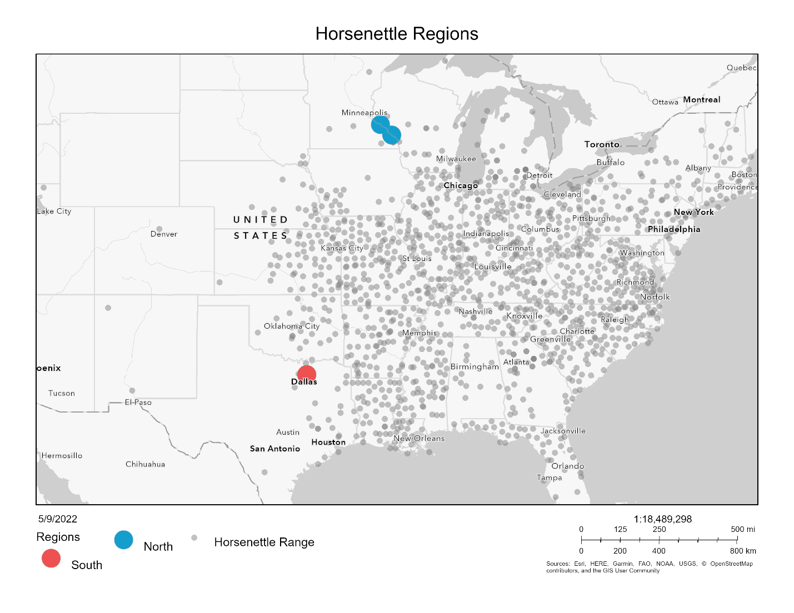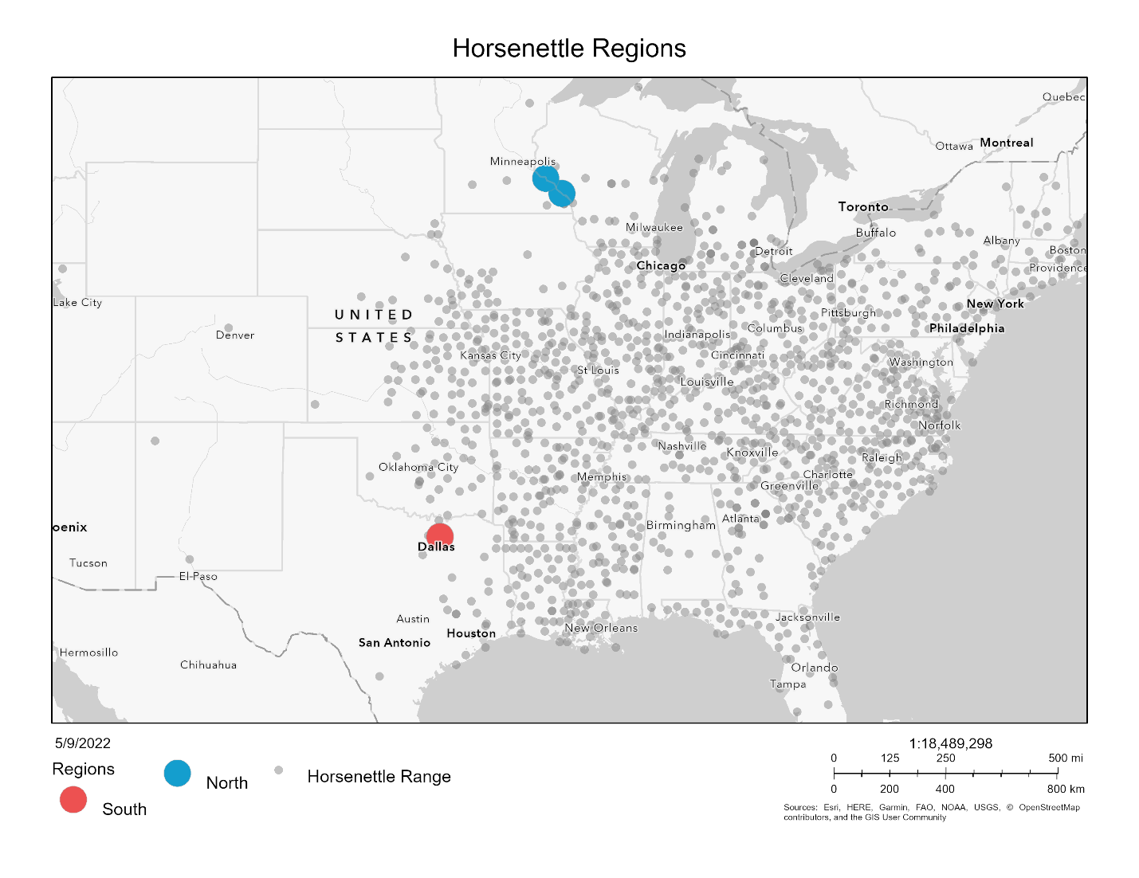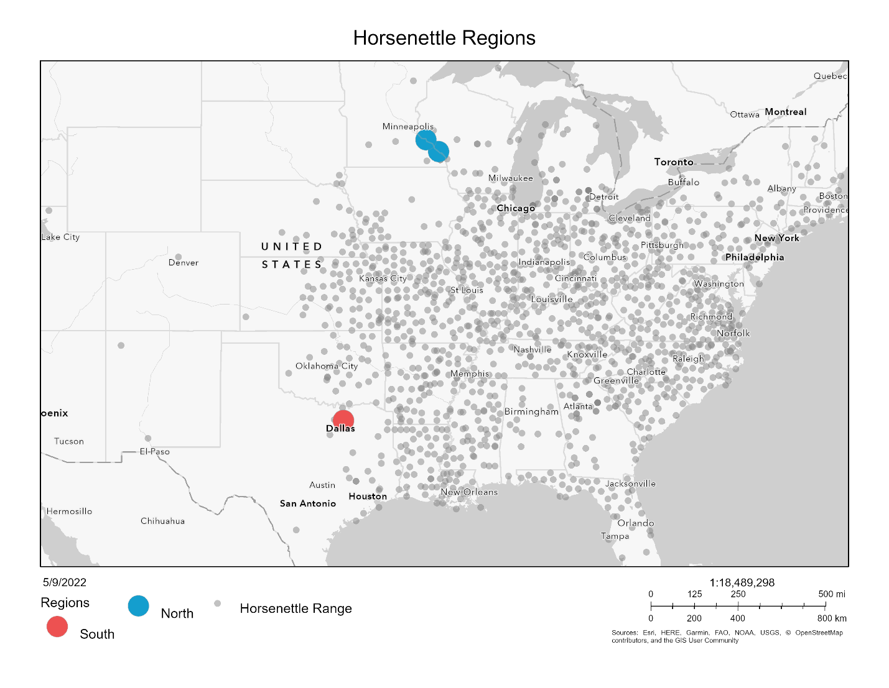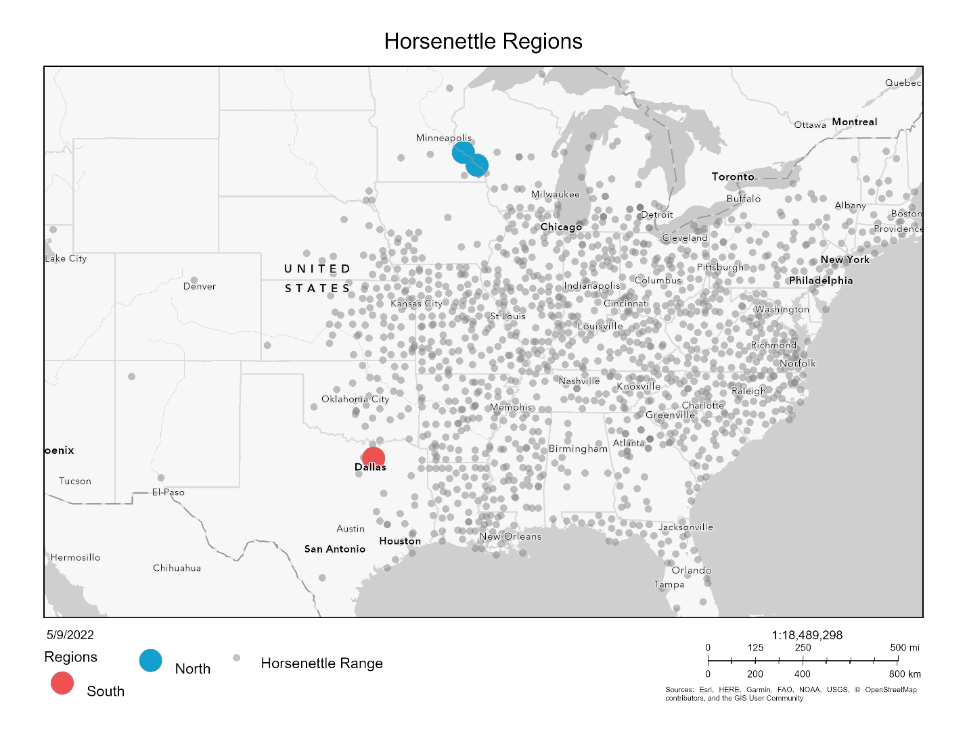

Figure 1. Map with collection site. Northern sites in blue and southern sites in red. Grey points indicate sites where *Solanum carolinense* was observed (data from EddsMaps).

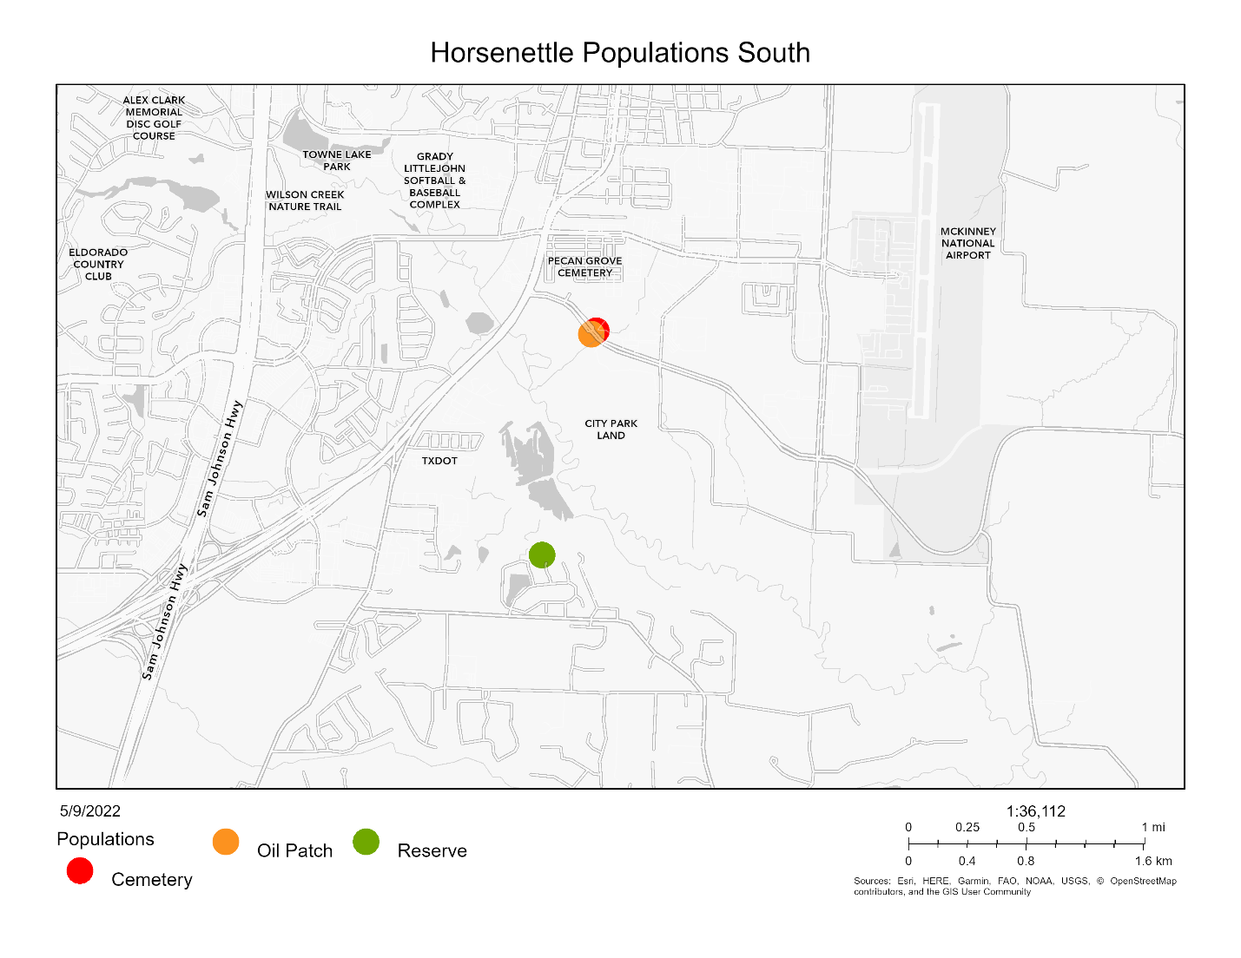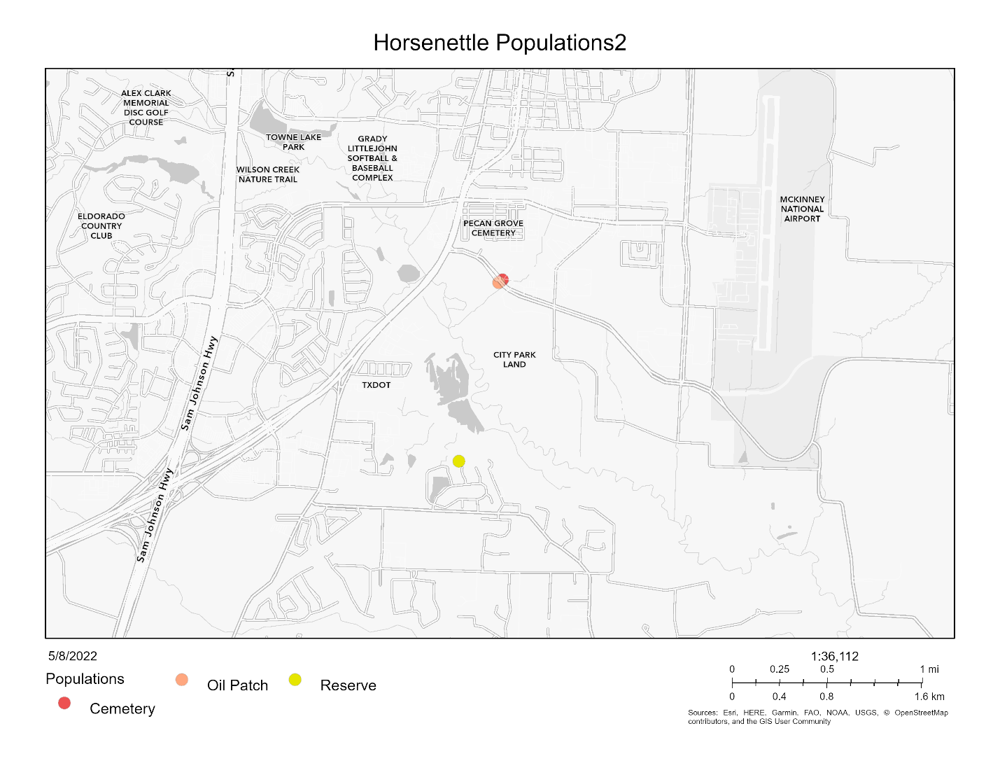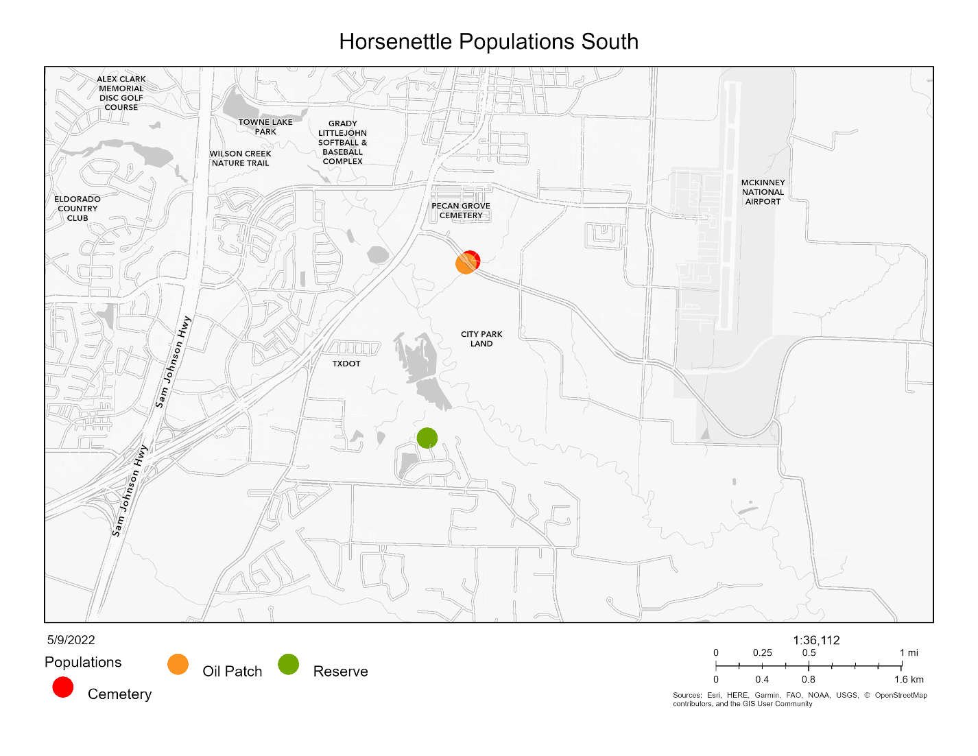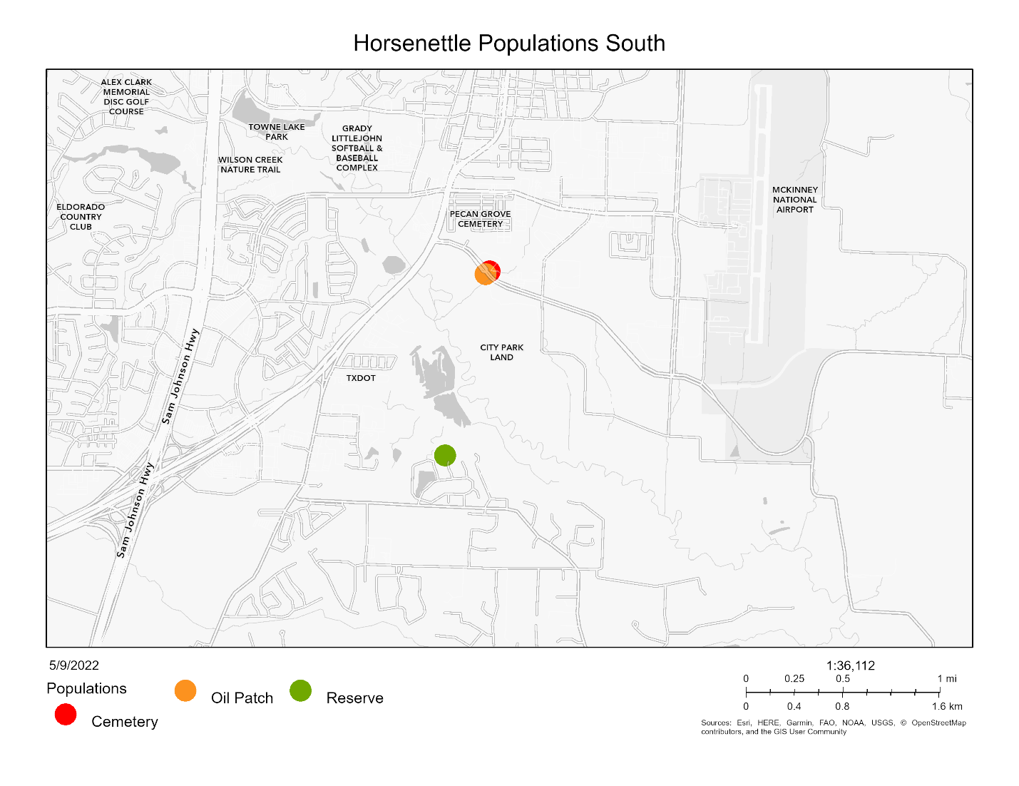

Figure 2. Populations in the southern region. Cemetery in red, Oil Patch in orange, and Reserve in green.

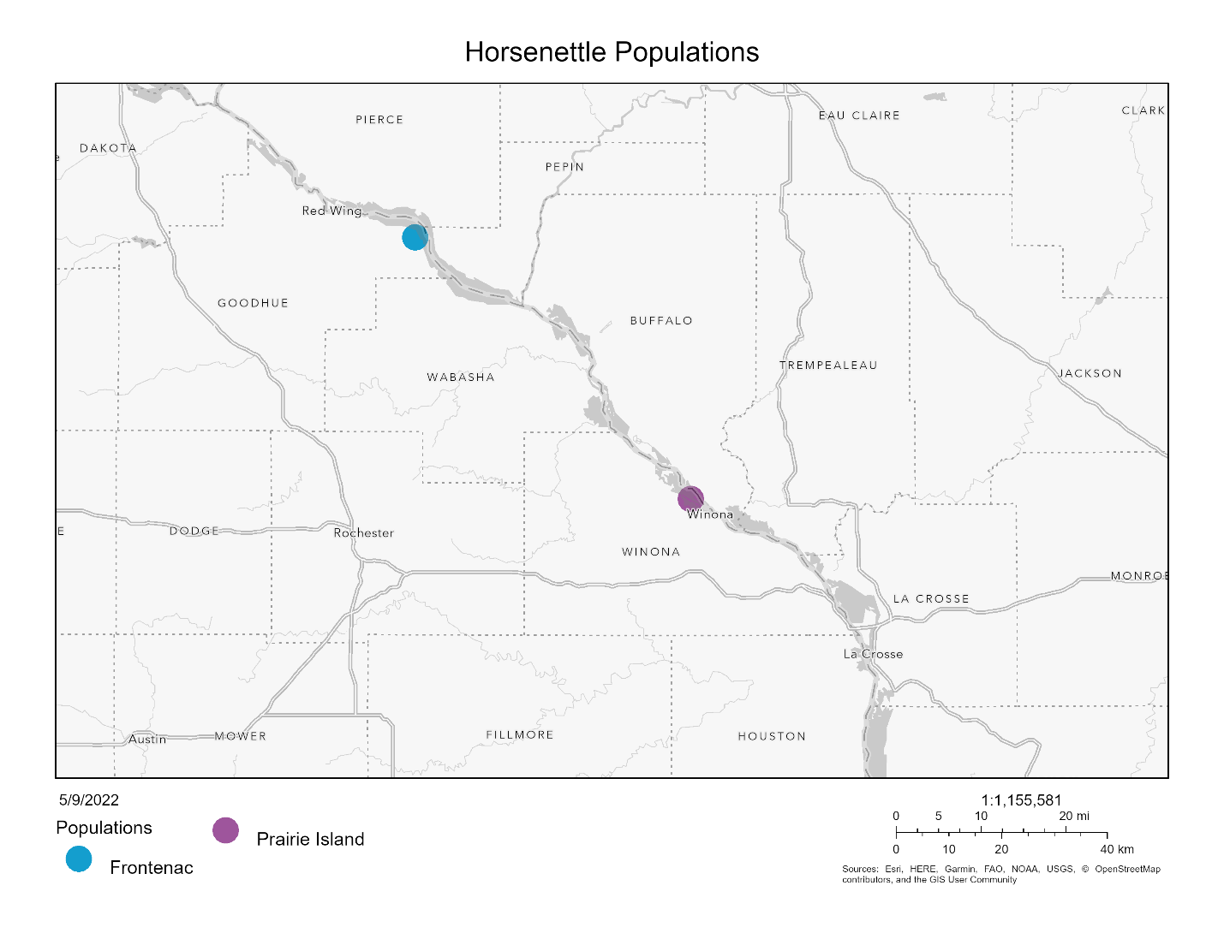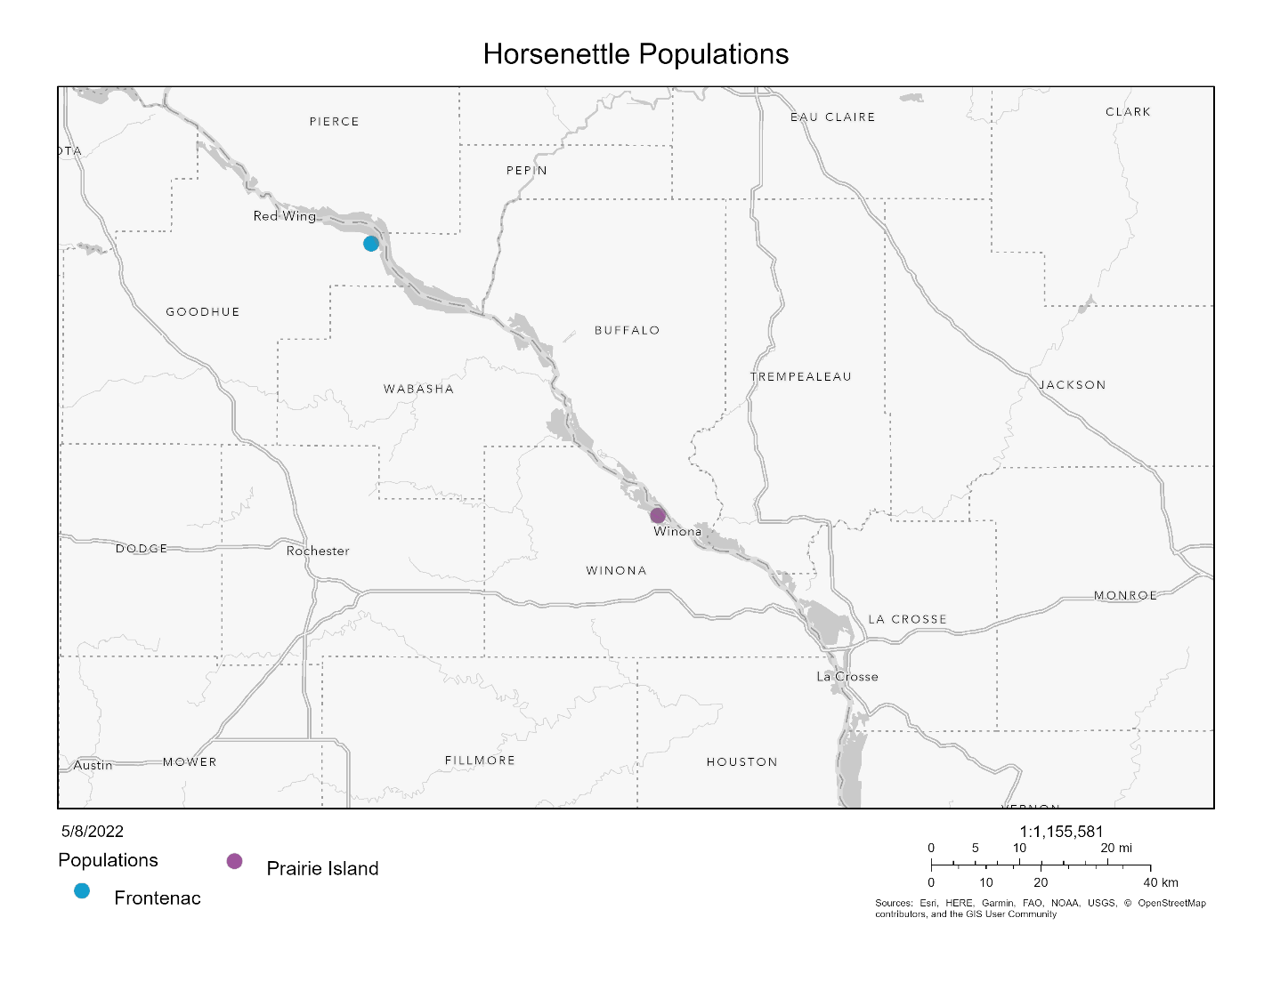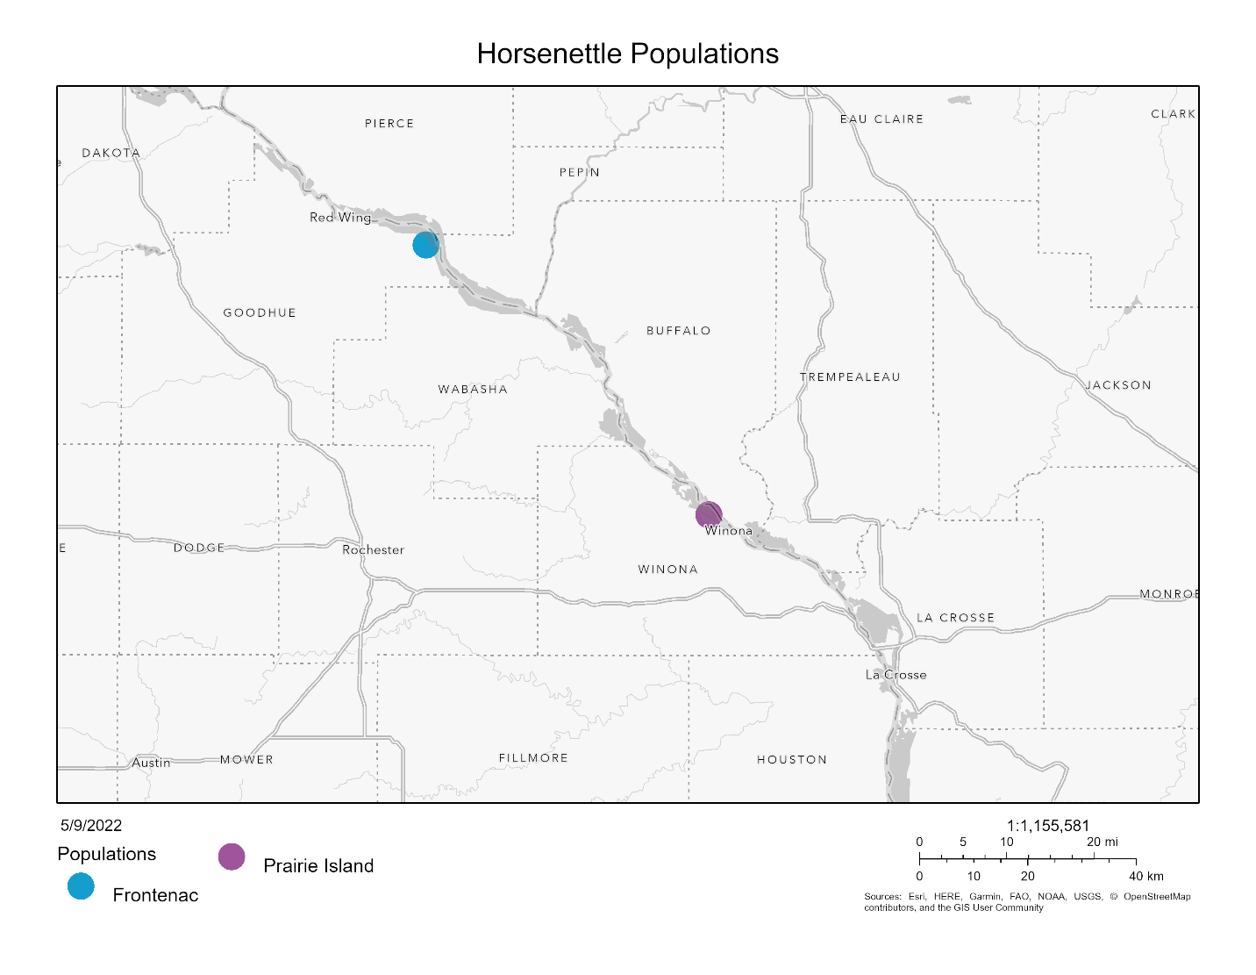

Figure 3. Populations in the northern region. Frontenac in blue and Prairie Island in purple.

***Greenhouse Experiment***

After the dormancy period (3 months), equal sections of rhizome were cut to grow ramets (genetically identical copies) in cone-shaped containers in the greenhouse. In total, four ramets (blocks A, B, C, and D) were grown from each genet (genetically independent), separated temporally. We started 10 or 12 ramets each week (sub-block 1-20), randomly selected from the 52 genets. Of the 10 or 12 ramets planted each week, half were from the southern region and half were from the northern region. All ramets in block A were planted over five weeks prior to the planting of the ramets in block B and so on. The northern ramets were randomly assigned to either the left or right side of the respective southern pair within the tray that held the cone-shaped containers. The plants were fertilized regularly and transplanted to larger containers when they outgrew the small cone-shaped containers. Once the plants had leaves of a reasonable size, we began collecting sporophytic measurements from one sub-block each week. Gametophytic data were measured when plants began flowering.

***Sporophytic Traits***

*Cell Membrane Stability*

We used a handheld conductivity meter to measure cell membrane stability (CMS) after a temperature treatment following the protocol of Gajanayake et al. (2011) and Fang and To (2016). Two large, intact leaves were removed from the middle of a plant and rinsed with deionized water. One leaf was used for the high temperature treatment and the second leaf was used for the cold temperature treatment. Twenty leaf rounds were punched from each leaf with a hole puncher. Ten of the 20 leaf rounds were placed in a test tube for the temperature treatment (high or low) and 10 were placed in a test tube for the control treatment.

Prior to the high temperature treatment, 10 mL of deionized water was added to the control and temperature treatment test tubes. The high temperature treatment test tubes were placed in a water bath at 55°C for 20 minutes, while the control test tubes were left at room temperature. Both tubes were moved to room temperature for 10 minutes prior to the first conductivity measurement.

The low temperature treatment test tubes were placed at 10°C for 24 hours followed by 24 hours at 4°C to acclimate the leaf rounds to cooler temperatures. The treatment tubes were then placed at -18°C for 1 hour. The control treatment tubes remained at room temperature. After the temperature treatment, 10 mL of deionized water were added to all tubes for both the treatment and control. The tubes were placed at room temperature for 1 hour prior to the first conductivity measurement.

All treatments groups were subjected to a maximum damage treatment after the first conductivity measurements to control for absolute amounts of leaf material. All test tubes were placed in a water bath at 98°C for 1 hour and then left to cool at room temperature for 15 minutes before the second conductivity measurement.

The cell membrane stability value (CMS) used for data analysis was calculated as one minus the proportion of treatment final to treatment group maximum divided by one minus the proportion of control final to control group maximum conductivity. Thus, larger values correspond with higher tolerance to temperature stress.

$$CMS= \frac{{{1-(Treatment}_{value}}/{{Treatment}_{max})}}{1-({{Control}_{value}}/{{Control}_{max})}}$$

*Chlorophyll Fluorescence Stability*

We used a chlorophyll meter to measure chlorophyll fluorescence stability (CHPL). Two intact leaves were removed from the middle of the plant. One leaf was used for the heat treatment and the other was used for the cold treatment. Each leaf was cut in half and one half was placed in the treatment temperature and the other half was placed in the control of room temperature. The CHPL was measured for both halves before and after the temperature treatment.

The high temperature treatment was 60°C for 1 hour. The leaf halves in the cold treatment were subjected to 4°C for 1 hour followed by 1 hour in -18°C. The leaf halves were moved to room temperature for two hours prior to the second cold treatment measurement. Leaves in all treatments were kept in complete darkness.

The CHPL value was calculated as the compliment of the difference between the proportions of treatment final to treatment initial and control final to control initial. Thus, larger values correspond with higher temperature tolerance.

$$CHPL= 1-\left(\frac{{Control}_{final}}{{Control}_{initial}}- \frac{{Treatment}_{final}}{{Treatment}_{initial}}\right)$$

*Net Photosynthetic Rate*

We used a LI-6400 infrared gas analyzer with a red/blue light source to measure photosynthetic rate before and after the temperature treatment. The following settings were used for photosynthesis measurements: flow rate 500 μmol s-1, reference CO2 420 μmol CO2 mol-1, reference H2O 0 mmol H2O mol-1, ParIn_μml 400 μmol m-2 s-1.

The high temperature treatment was 33°C and the low temperature treatment was 10°C. Since full plants were placed in the temperature treatments, measurements were taken later in the fall after data were collected for all other sporophytic and gametophytic traits. All four ramets, if alive, for the 52 genets were subjected to both treatments with a rest period of one week between the temperature treatments. Several plants died or lost leaves by that time net photosynthetic rate was measured and thus were not included. Ramets A and C were subjected to the high temperature treatment first and ramets B and D were subjected to the low temperature treatment first. The proportion of the photosynthetic rate measurement after the treatment to before was calculated as our measure of photosynthetic rate (PS). Any values below zero and above one were omitted prior to analysis.

$$PS= \frac{{Net Photosynthetic rate}_{final}}{{Net Photosynthetic rate}_{initial}}$$

***Gametophytic Traits***

We measured two pollen traits as estimates of male thermotolerance during the gametophytic stage: 1) the propensity for pollen grains to germinate (pollen germination) and 2) the growth rate of pollen tubes while exposed to a range of temperatures. Once a plant from the north and from the south flowered, we removed a mature flower from both plants. Since *Solanum carolinense* is buzz pollinated, a device crafted from a nose hair remover and a paper clip was used to mimic the vibrations needed to release pollen from the anther. Pollen from each flower was thus dispersed over five petri dishes containing 3% Bacto-Agar based growth medium (sucrose, Ca(NO3)2, MgSO4, KNO3, H3BO3) following the protocol of Reddy and Kakani (2007). The dusted plates were each placed at one of the five temperature treatments (10°C, 20°C, 25°C, 30°C, 40°C) for 16 hours in a refrigerator (10°C), Coviron E7/2 environmental chamber (20°C), and three drying ovens (25°C, 30°C, 40°C). After the temperature treatments, the plate was covered with a thin layer of ethanol to halt further pollen tube growth and stored until data collection could begin. Four pictures of each plate were taken using a microscope. Pollen did not evenly cover petri dishes; therefore, pictures were taken in locations where pollen was visible. The petri dish was positioned so pollen visible to the naked eye (miniscule white spots) was under the objective. The petri dish was not repositioned once pollen grains were viewed magnified to avoid sampling bias when taking the pictures.

Pollen germination was measured by counting the number of pollen grains that produced pollen tubes and the number of pollen grains that did not produce pollen tubes in a picture. All pollen grains in a picture were counted until at least 100 pollen grains were observed starting with the first picture taken. Pollen germination was considered as the production of a tube that was at least half the diameter of the pollen grain. We used the percent of pollen grains with tubes out of the total number of pollen grains as our measure of pollen germination.

Pollen tube growth rate was determined by first measuring the 10 longest pollen tubes in each of the 4 pictures using the software ImageJ (Schneider et al., 2012). The actual length of each tube was calculated by calibrating each photo with a measurement of a stage micrometer. We calculated the mean of the 20 longest tubes out of the 40 measured per plate and used that to estimate growth rate by dividing the length by the time allowed for growth (16 hours). Pollen tubes were only included if they were completely visible in the picture.

***Data Analysis***

All data were analyzed in R 4.1.2 (R Core Team, 2020). In order to measure differences in sporophytic traits between regions and among genets, we fit linear mixed effects models using the lmer function from the *lmerTest* package (Kuznetsova et al., 2017). Region (north vs. south) was considered the fixed effect and block (A, B, C, D) and genet nested in population as random effects. We dropped the genet nested in population term for cell membrane stability and both random effects terms for hot net photosynthetic rate to avoid overfitting the model. Since the genet nested in population term was significant for some variables, we compared population and genets independently. Populations were compared using a linear mixed effects model (*lmerTest*; function lmer) with population as the fixed effect and block as the random effect. We used an analysis of variance model in the *stats* package (R Core Team, 2020), to determine if there were differences between genets for each of the sporophytic variables. Since there was a significant block effect in some of the variables, we compared plants from the north and south within block using a paired t-test (*stats*; function t.test). To determine if variation within the northern and southern regions differed, we used the bartlett’s test of homogeneity of variance (*stats*; function bartlett.test).

For the gametophytic variables, we fit temperature performance curves using the nls.multstart function in the *rTPC* package (Padfield & O'Sullivan, 2021) to the multiple temperature measurements taken for each plant that flowered. Of the 25 temperature performance curves available in the *rTPC* package, the quadratic_2008 and the weibull_1995 models had the lowest AIC values. The weibull_1995 model was eliminated from our analyses because maximum values extracted by the weibull_1995 model were infinite for some of the plants. From the quadratic curves each plant that flowered, we extracted six cardinal values: the temperature minimum (germination or growth rate = 0), temperature optimum (germination or growth rate maximized), and temperature maximum (germination or growth rate = 0) used analysis of variance (*stats*; function aov) on each of the cardinal values to determine if there were differences between region and among genets. One outlier was identified using the Grubbs test for one outlier using the grubbs.test function in the *outliers* package (Komsta, 2011) and subsequently dropped from the analysis.

We used correlation analysis (*stats*; function cor) using Pearson’s method to determine if there were any correlations between sporophytic and gametophytic variables. We conducted correlation analysis for all plants together and then the northern and southern plants separately. To incorporate relationships between all of the variables and examine amalgamated differences among regions and populations, we conducted principal component analysis (PCA) (*stats*; function prcomp). We first conducted PCA on all the sporophytic variables and all gametophytic variables separately and then all of them collectively. Photosynthetic rate was not included because of limited sample size. We extracted the eigenvalues for the first three principal components for all three PCAs. The eigenvalues for each principal component were compared for the two regions using t-tests (*stats*; function t.test).

**Results**

***Sporophytic Variables***

Cell Membrane Stability

Cell membrane stability (CMS) equals the ratio of a conductivity measurement after a temperature treatment to a conductivity measurement after a maximum damage treatment. An increased CMS ratio indicates higher tolerance of the temperature treatment (Gajanayake et al., 2011). When *Solanum carolinense* plants from the north were compared to the south, we found no significant difference in the hot treatment (HCMS), but there was a significant difference in the cold treatment (CCMS; Figure 4, Table 1). Southern plants had significantly higher CCMS values than northern plants. We found a significant difference among genotypes in the hot treatment, but not in the cold treatment (Figure 5, Table 1).

Because we could not grow all the experimental plants at the same time due to lack of space, we made the above comparisons among regions and genotypes in five different temporal blocks over the course of the spring and summer. To avoid confounding treatments with temporal effects plants from different regions were paired with each other within blocks. When we tested for the presence of block effects, we found significant effects for both hot and cold CMS (Figure 6). Plants grown at different times in the greenhouse had different CMS ratios. We started growing the plants in the winter and early spring and outside temperatures gradually rose during that time (Appendix). Acclimation to higher temperatures later in the year could account for the block differences observed. To remove block effects, we conducted paired t-tests of northern versus southern plants for each of the variables. When plants from the north and south were compared for HCMS, there was a significant difference between the regions (Figure 6) but only in the first block. In that block, northern plants had a higher HCMS than those from the south. For CCMS, there was a significant difference between regions for blocks B and C (Figure 6). In both cases, southern plants were more tolerant of the cold temperatures than northern plants.

Chlorophyll fluorescence stability

Chlorophyll fluorescence was measured before and after either a heat stress (HCHPL) or cold stress (CCHPL) and the calculated value that incorporates the two measurements (CHPL) was used as a proxy for temperature tolerance. As the CHPL increases, the individual sporophyte is more tolerant of the temperature treatment (Gajanayake et al., 2011). There was a significant difference between plants originating in the north and south for both the hot and cold treatments (Figure 4). Northern plants were more tolerant of both heat and cold than were southern plants regardless of block (Table 1). We found a significant difference among individual genotypes for the cold treatment, but not for the hot treatment (Figure 5, Table 1). The two regions also differed in variation for HCHPL. In the hot treatment, northern plants had significantly more variation than southern plants (Bartlett’s test p-value = 1.68E-4; Figure 7). No other variable showed a difference in variance between the two regions.

Net Photosynthetic Rate

We used net photosynthetic rate after thermal stress as a physiological indicator of temperature tolerance. Net photosynthetic rate (PS) is the proportion of the net photosynthetic rate after the treatment (heat and cold) to the net photosynthetic rate before the treatment. Increased PS indicates higher temperature tolerance of the thermal stress (Poudyal et al., 2019). For both the cold (CPS) and hot (HPS) treatments, there was no significant difference between north and south (Figure 4, Table 1). There were also no significant differences among blocks and genotypes for both the hot and cold treatments.

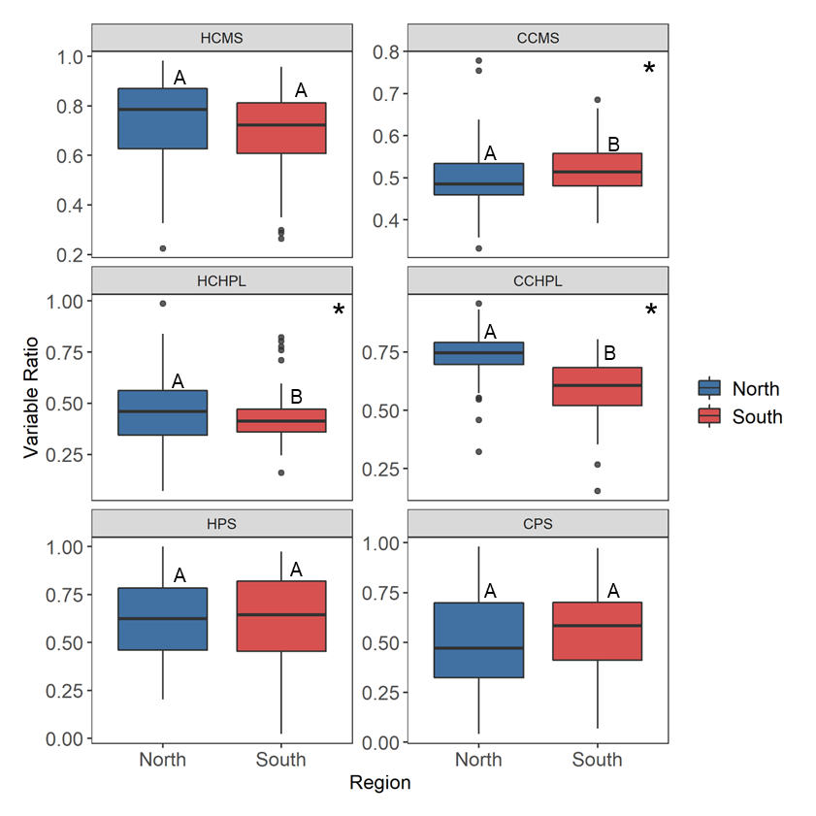Figure 4. Regional differences for temperature tolerance traits including hot and cold cell membrane stability (HCMS, CCMS), hot and cold chlorophyll fluorescence stability (HCHPL, CCHPL), hot and cold net photosynthetic rate (HPS, CPS). Center line of boxplot is the median value for the region. The letters represent statistically significant differences between regions. Variables with significant differences denoted with asterisks: CCMS (F1,50 = 7.792, p = 0.006), HCHPL (F1,51 = 4.334, p = 0.043), and CCHPL (F1,50 = 64.652, p = 1.6e-10).

Table 1. Results from the mixed linear model for the difference in region (north vs south) and the one-way analysis of variance results for the difference between individual genets. Red font color highlights observed outcomes when the result was different from the expected pattern. Asterisk indicates analysis with one outlier removed determined using Grubbs test for one outlier.

|  |  |  |  |  |  |  |
| --- | --- | --- | --- | --- | --- | --- |
|  |  | **Region** | | | **Genet** | |
|  | **Variable** | **Expected** | **Observed** | **p-value** | **Observed** | **p-value** |
| **Sporophyte** | Cell Membrane Stability (Heat) | S > N | - | 0.06102 | **Yes** | **0.013** |
| Cell Membrane Stability (Cold) | N > S | **S > N** | **0.0117** | No | 0.886 |
| Chlorophyll Fluorescence (Heat) | S > N | **N > S** | **0.0405** | No | 0.38 |
| Chlorophyll Fluorescence (Cold) | N > S | N > S | **9.96E-11** | **Yes** | **1.05E-07** |
| Photosynthetic Rate (Heat) | S > N | - | 0.997 | No | 0.127 |
| Photosynthetic Rate (Cold) | N > S | - | 0.77 | No | 0.883 |
| **Gametophyte** | Pollen Germination (Tmax) | S > N | **N > S** | **0.00037** | **Yes** | **0.0251** |
| Pollen Germination (Topt) | S > N | **N > S** | **0.000685** | **Yes** | **0.0351** |
| Pollen Germination (Tmin) | S > N | - | 0.331 | **Yes** | **\*0.0135** |
| Pollen Tube Growth Rate (Tmax) | S > N | - | 0.568 | No | 0.418 |
| Pollen Tube Growth Rate (Topt) | S > N | - | 0.77 | No | 0.608 |
| Pollen Tube Growth Rate (Tmin) | S > N | - | 0.683 | No | 0.496 |

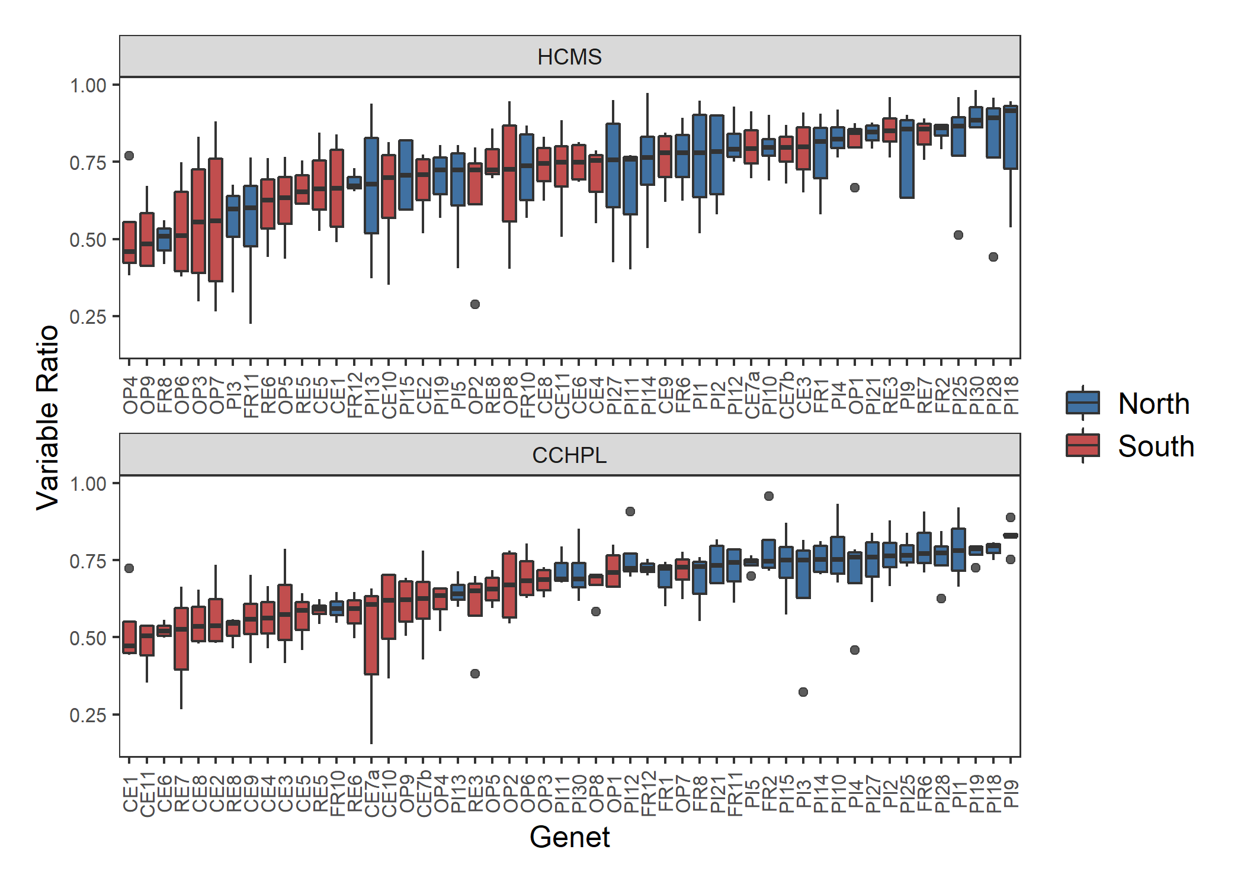

Figure 5. Genotype differences for temperature tolerance traits including hot cell membrane stability (HCMS) and cold chlorophyll fluorescence stability (CCHPL). Genets ordered by increasing ratio for each variable. Center line in boxplot is the median of the measurements taken for the ramets of one genet. There is a significant difference among the genets for HCMS (F = 1.5, p = 0.029) and CCHPL (F = 3.341, p = 6.1e-9). Plots of genet effect for other variables in appendix.

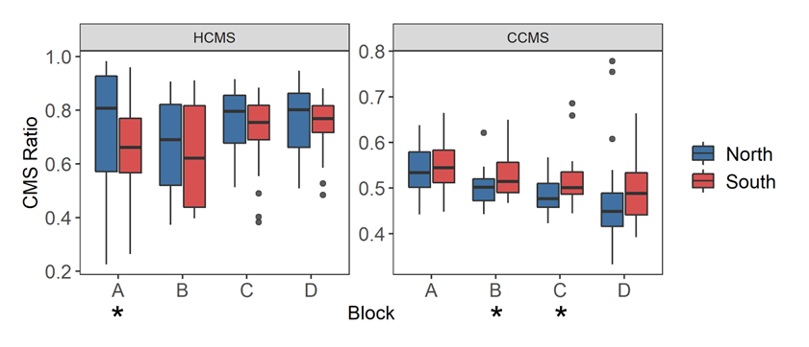

Figure 6. Cell membrane stability across temporally independent blocks and colored by region. The center line of the boxplot is the median of the measurements taken for each region within a ramet. There is a significant difference between blocks for hot cell membrane stability (HCMS, p = 0.0297) and cold cell membrane stability (CCMS, p = 7.30e-05). Astrisks indicate a significant difference between regions from a paired t-test of regions for each block independently. There was a significant difference between regions for HCMS block A (t = -2.910, p = 0.015), CMS block B (t = 2.190, p = 0.040), and CMS block C (t = 2.073, p = 0.049). Results from paired t-tests between blocks for each variable located in the appendix.

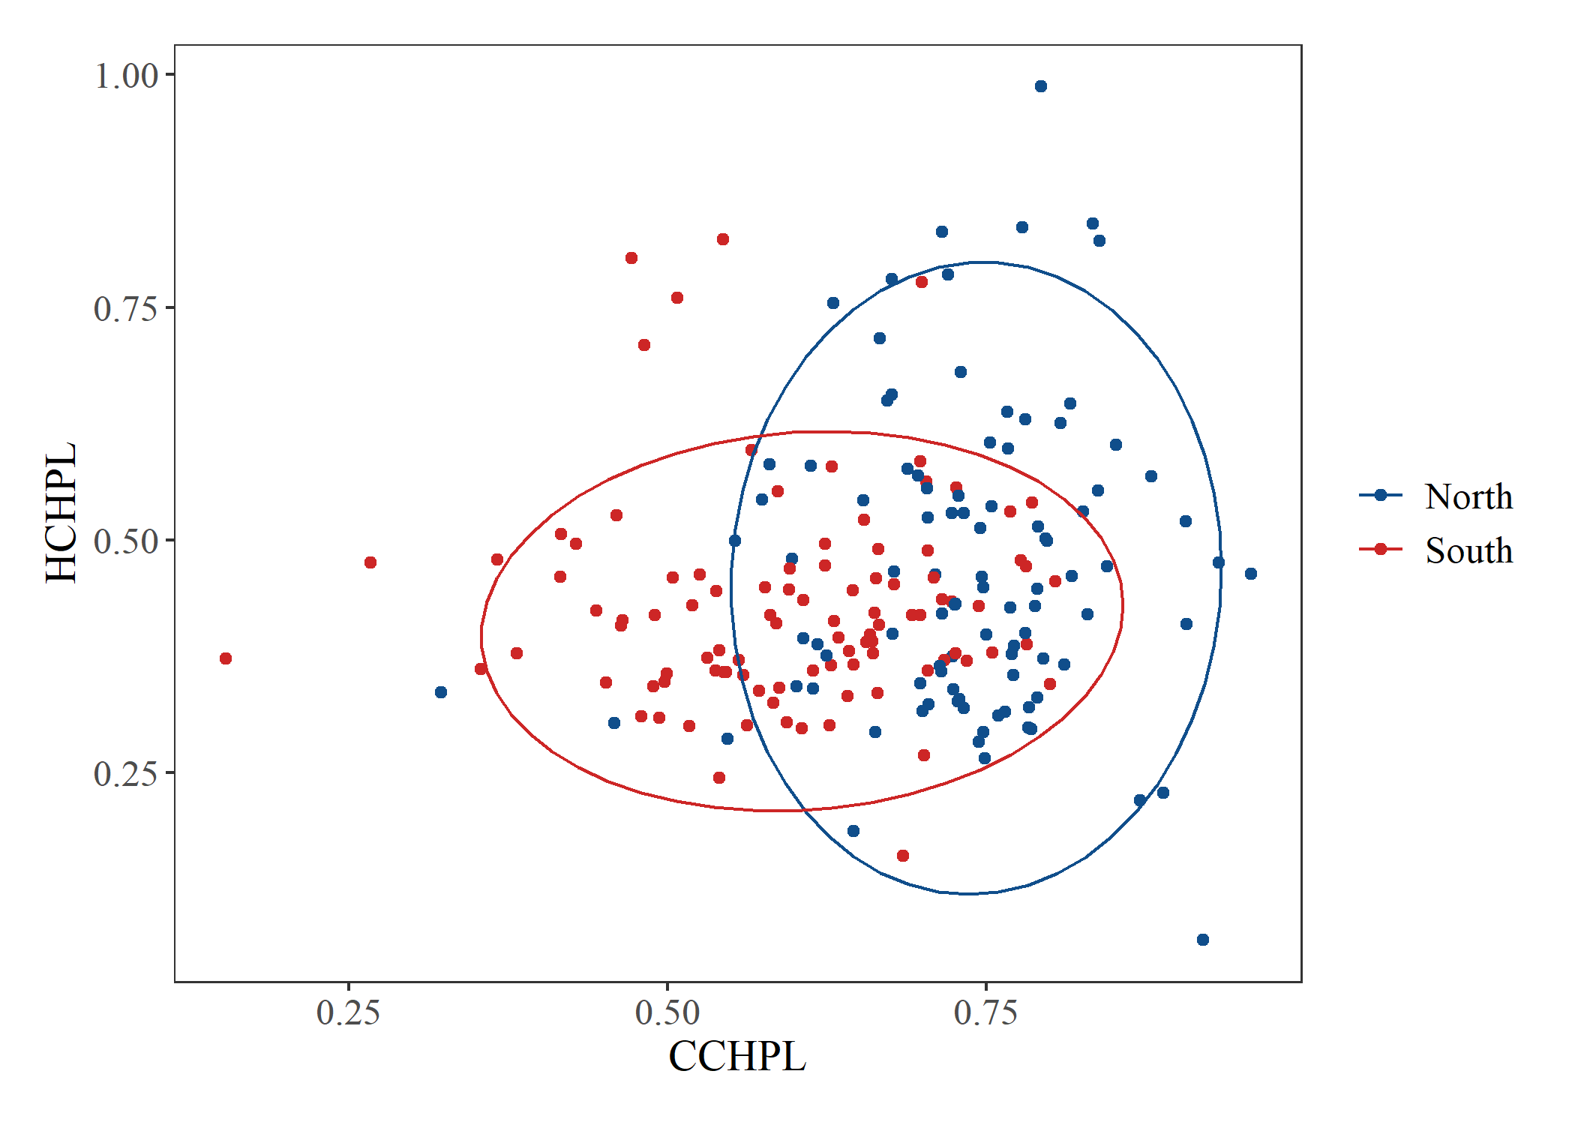

Figure 7. Hot chlorophyll fluorescence stability (HCHPL) vs cold chlorophyll fluorescence stability (CCHPL) for plants from the north and south. Ellipse indicating 95% confidence interval for multivariate T distribution. Results from Bartlett’s test for heterogeneity of variance between regions for all variable located in the appendix.

***Gametophytic Traits***

Pollen Germination

We fit quadratic curves to temperature performance profiles of each plant for pollen germination at five temperatures (Figure 8). From the quadratic fit, we calculated the minimum (Tmin), maximum (Tmax), and optimal (Topt) temperature of pollen germination for each individual. There was a significant difference between regions for Tmax and Topt (Figure 8, 9). Plants from the north germinated more readily at high temperatures and had higher thermal optima than plants from the south. There was no significant difference between the two regions for Tmin. The genets were significantly different from one another for Tmin, Tmax, and Topt (Figure 10). One outlier was identified using the Grubbs test for one outlier (outliers; function grubbs.test) and subsequently dropped from the analysis.

Pollen Tube Growth Rate

The pollen tube growth rates for each individual were also fit with a quadratic curve to estimate the Tmin, Tmax, and Topt. There were no significant differences between plants from the north and south for each of the three variables (Appendix). There were also no significant differences among genets (Appendix).

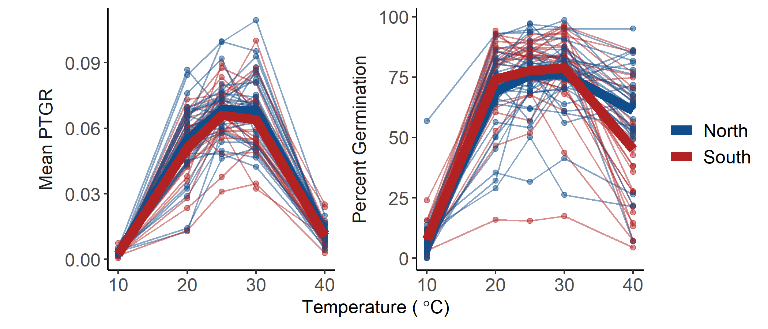

Figure 8. Percent germination and mean pollen tube growth rate (PTGR) for *Solanum carolinense* pollen grains from the north (blue) and south (red) across a temperature gradient (10°C, 20°C, 25°C, 30°C, 40°C). Thin lines and points represent each individual plant that flowered. Thick lines indicate the mean value for the region at each temperature.

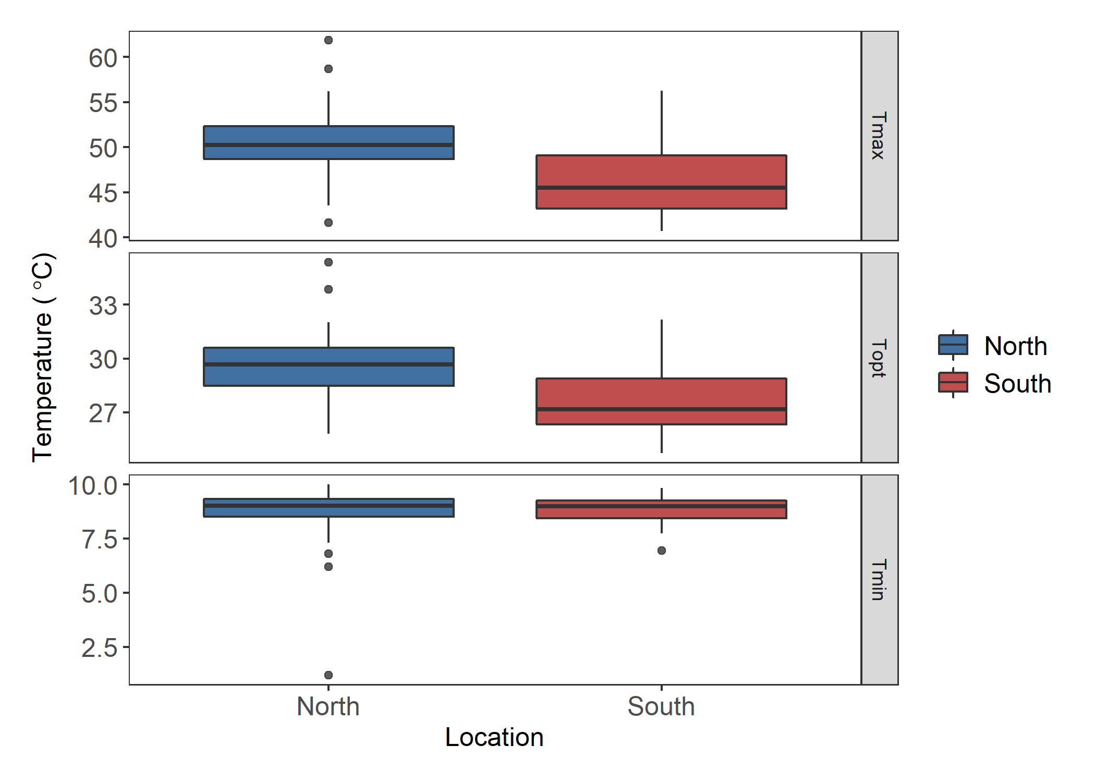

A

B

*

A

B

*

A

A

Figure 9. Estimates for the maximum (Tmax), optimal (Topt), and minimum (Tmin) germination temperature extracted from quadratic fits of the germination data for each individual. Asterisks and different letters indicate significant differences. There is a significant difference between regions for Tmax (F = 14.28, p = 3.7E-4) and Topt (F = 12.85, p = 6.85E-4).

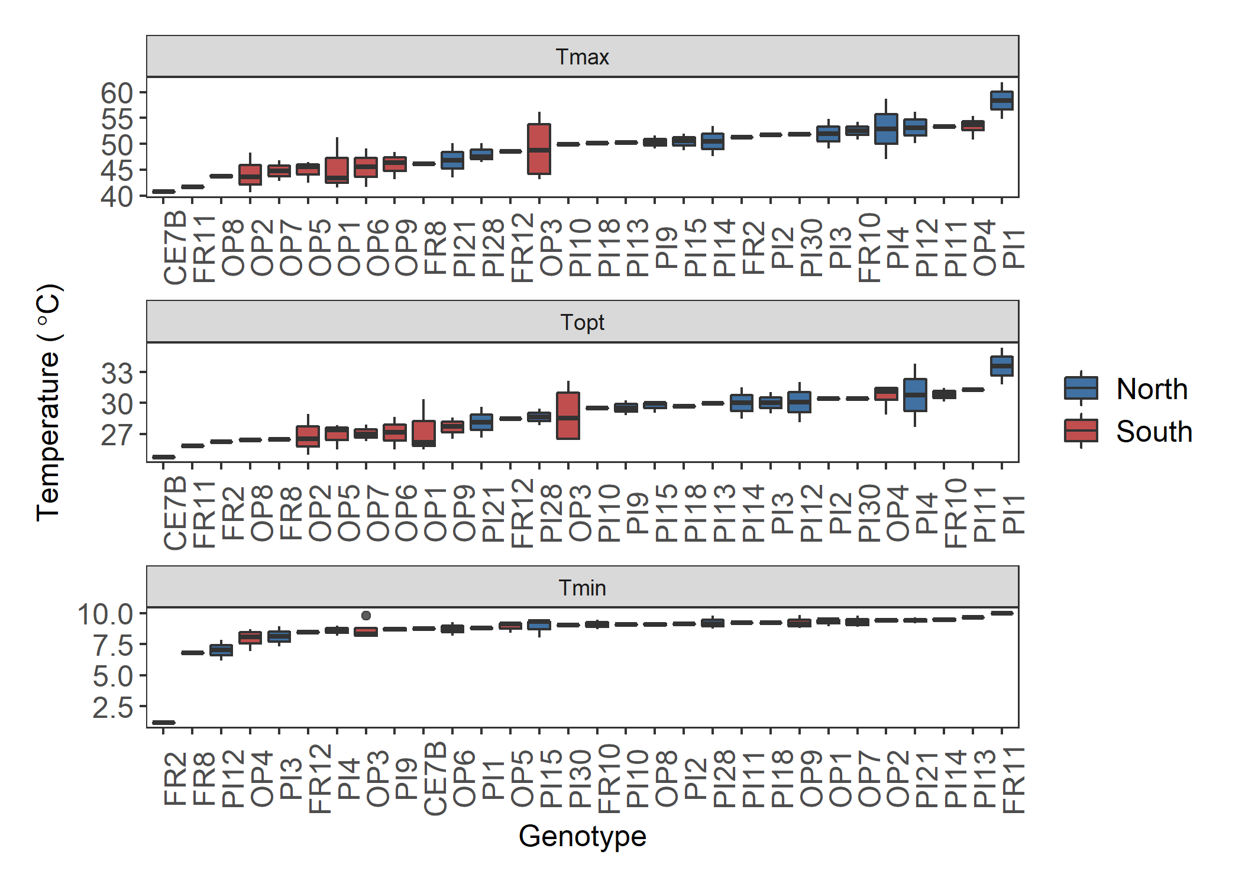

*

Figure 10. Boxplots of the maximum (Tmax), optimal (Topt), and minimum (Tmin) pollen germination temperatures by genet. There is a significant difference between the genets for Tmax (F = 2.064, p = 0.025), Topt (F = 1.952, p = 0.035), and Tmin (F = 2.284, p = 0.0135). Asterisk indicates the outlier removed for analysis. Plots of genet effect for other variables in appendix.

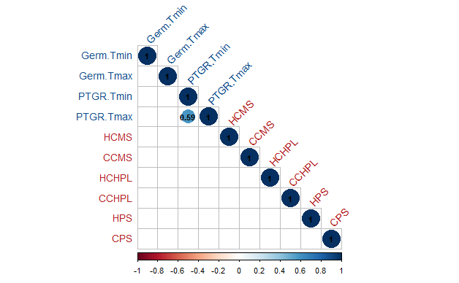

Figure 11. Correlation matrix of northern plants. Sporophytic (labels blue font) and gametophytic variables (labels red font) with significant Pearson’s correlations for all study plants. Blue fill colors indicate positive correlations and red fill colors indicate negative correlations.

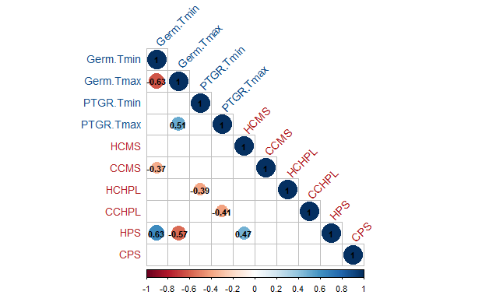

Figure 12. Correlation matrix of southern plants. Sporophytic (labels blue font) and gametophytic variables (labels red font) with significant Pearson’s correlations are included. Blue fill colors indicate positive correlations and red fill colors indicate negative correlations.

***Correlations***

We used correlation analysis to identify relationships between hot and cold tolerance for the sporophytic and gametophytic variables. Pearson’s correlations were determined for all pairings of variables. When all plants were included, there were no significant correlations between the gametophytic and sporophytic variables (Appendix). However, three of the six sporophytic variables were significantly correlated (correlation plots located in appendix). HCMS was weekly correlated with HPS (correlation = 0.19), CPS (correlation = 0.2), and CCHPL (correlation = 0.15) There were also three significant correlation coefficients between gametophytic variables. Maximum and minimum pollen tube growth rate were positively correlated (correlation = 0.45). Maximum and minimum pollen germination were negatively correlated (correlation = -0.33). Maximum pollen tube growth rate and maximum pollen germination were positively correlated (correlation = 0.3).

When the correlation analysis was performed for the regions separately, there were different results. For the northern plants, there was only one significant correlation; between HPTGR and CPTGR (Pearson’s correlation 0.59; Figure 11). The southern plants had several significant correlations (Figure 12). There was a significant correlation between HCMS and HPS (correlation = 0.47), between Tmin germination (Germ.Tmin) and Tmax germination (Germ.Tmax) (correlation = -0.63) and between Tmax PTGR (PTGR.Tmax) and Tmin PTGR (PTGR.Tmin) (correlation = 0.51). In addition, there were correlations between variables in the gametophytic and sporophytic life stages. Germ.Tmin was negatively related to CCMS (correlation = -0.37) and positively related to HPS (correlation = 0.63). Germ.Tmax was also related to HPS (correlation = -0.57), but negatively. HCHPL and PTGR.Tmin were negatively correlated (correlation = -0.39), while CCHPL is negatively related to PTGR.Tmax (correlation = -0.41).

***Principal Component Analysis***

We conducted principal component analysis to further explore relationships among all variables and the sporophytic and gametophytic variables separately. For the full PCA, we included all gametophytic and sporophytic variables, except HPS and CPS due to inadequate sample size. The first three principal components accounted for 57% of the variation (full PCA plots and loadings in the appendix). There was little divergence between regions (Appendix). When the eigenvalues of the principal components were compared between regions, PC2 was the only principal component that showed a significant difference (t58 = -2.69, p = 0.0092). Chlorophyll fluorescence (HCHPL and CCHPL) loads primarily on PC2 and is likely driving the divergence between northern and southern plants.

*Sporophytic PCA*

In the sporophytic variables PCA, the first three principal components explained 60% of the variation. The variables HCMS and HPS primarily loaded on PC1 (Table 2, Figure 13). The second and third principal components were mostly influenced by CCHPL and HCHPL respectively. There was a significant difference between the regions for the eigenvalues extracted from both PC2 (t78 = -5.09, p = 2.39e-06) and PC3 (t101 = 2.38, p = 0.019). The divergence in PC2 can be explained by the opposite responses we observed for CCMS and both chlorophyll fluorescence treatments. Northern plants have a higher chlorophyll fluorescence ratio for both treatments, while southern plants had less cell membrane damage in the cold treatment. PC1 did divide HCMS and CCMS, suggesting an antagonistic relationship between the two variables, though there was no correlation between the two that was statistically significant. Hot and cold treatment variables were also divided on PC3. HPS and HCHPL were opposite in direction to CPS and CCHPL.

*Gametophytic PCA*

In the gametophytic PCA, the first three components explained 92.5% of the variance. Pollen germination variables divided the northern and southern plants (Figure 14). Tmax and Topt loaded evenly in the opposite direction of Tmin for both PC1 and PC2 (Table 3, Figure 14). There was a significant difference between north and south for the eigenvalues extracted from PC2 (t46 = -3.17, p = 0.0025). PTGR variables loaded evenly on the first two principal components, indicated by the common diagonal direction among the PTGR variables (Table 3, Figure 14).

Figure 13. Plots of the results of principal component analysis for the sporophytic variables. A) PC1 and PC2, B) PC2 and PC3, C) PC1 and PC3. Ellipsoid indicating 95% confidence interval. PC1 explains 22.38% of the variance, PC2 explains 21.55% of the variance, and PC3 explains 16.79% of the variance. Tables with principal component importance for PC1 through PC6 in the Appendix.

Table 2. Results from principal component analysis of only sporophytic variables. Loadings for each of the variables on the principal components

|  |  |  |  |  |  |  |
| --- | --- | --- | --- | --- | --- | --- |
|  | **PC1** | **PC2** | **PC3** | **PC4** | **PC5** | **PC6** |
| **HCMS** | 0.613999 | 0.02998 | 0.344975 | 0.147492 | 0.573797 | 0.390002 |
| **CCMS** | -0.35207 | 0.435008 | 0.204072 | -0.57534 | 0.520509 | -0.20789 |
| **HCHPL** | 0.284794 | -0.36797 | -0.33836 | -0.75803 | -0.08744 | 0.294536 |
| **CCHPL** | 0.117118 | -0.57752 | 0.579996 | -0.14114 | -0.03843 | -0.5431 |
| **HPS** | 0.577968 | 0.302596 | -0.40867 | 0.000171 | 0.044159 | -0.63673 |
| **CPS** | 0.264909 | 0.499375 | 0.470594 | -0.22955 | -0.6235 | 0.13244 |

Figure 14. Plot of the results of principal component analysis of the gametophytic variables. PC1 describes 48% of the variation and PC2 explains 27%. A table of importance of principle components 1 through 6 is in the Appendix.

Table 3. Results from principal component analysis of only gametophytic variables. Loadings for each of the variables on the principal components

|  |  |  |  |  |  |  |
| --- | --- | --- | --- | --- | --- | --- |
|  | **PC1** | **PC2** | **PC3** | **PC4** | **PC5** | **PC6** |
| **Germ.Tmin** | -0.01334 | 0.405643 | 0.812217 | 0.376238 | -0.00058 | -0.18446 |
| **Germ.Topt** | 0.418665 | -0.45436 | 0.390064 | -0.00262 | 0.001723 | 0.682727 |
| **Germ.Tmax** | 0.407763 | -0.5446 | 0.164764 | -0.10069 | -0.00179 | -0.707 |
| **PTGR.Tmin** | 0.367661 | 0.452838 | 0.127813 | -0.75119 | -0.28131 | 0.00071 |
| **PTGR.Topt** | 0.523981 | 0.308129 | -0.20261 | 0.123985 | 0.757676 | -0.00193 |
| **PTGR.Tmax** | 0.498538 | 0.180049 | -0.3219 | 0.518304 | -0.58888 | 0.001496 |

**Discussion**

***Regional Differences***

If *Solanum carolinense* has locally adapted to the respective temperature regimes in TX and MN, we would expect that plants from the north would be more tolerant of cold temperatures and plants from the south would be more tolerant of hot temperatures. Rather than a clear-cut difference between north and south for hot and cold treatments, there were mixed results that support divergence between regions in ways we hadn’t anticipated.

*Sporophyte*

Plants from the south had a more stable cell membranes when exposed to an extreme cold treatment. Cold stress reduces the fluidity of the cell membrane and produces ROS that have the potential to oxidize lipids and damage the membrane (Valitova et al., 2019). The incorporation of sterols in membranes can maintain fluidity and expand temperature range for plants (Dufourc, 2008a, 2008b; Valitova et al., 2019). Conversely, saturated fatty acids can be incorporated in the cell membrane to reduce fluidity and are often associated heat tolerance (Knight & Ackerly, 2001; Zhu et al., 2018). There was no significant difference between region for HCMS for all study plants together, but there was a significant difference for plants in block A. Temperatures in the greenhouse progressively rose throughout the spring and summer leading to a block effect in both the hot and cold treatments of CMS. In block A for HCMS measurements, northern plants had a higher HCMS, but this difference degraded in the later blocks during the times when temperatures were higher. Southern plants may have the capacity to induce heat tolerance as they acclimate to warmer conditions. Block A may be the best representative measurement of baseline heat tolerance for HCMS, but the later blocks suggest that CMS is a plastic trait. The median of HCMS generally increased across blocks, while the median of CCMS decreased. While there was no significant correlation between CCMS and HCMS, these results suggest that HCMS and CCMS are inversely related. Our PCA results also showed an antagonistic relationship between the CMS variables as they were loaded in opposite directions for PC1 and PC2 in the sporophytic PCA.

HCMS was an important variable in the correlation analysis that included all plants. HCMS was weakly and positively correlated with CCHPL, CPS, and HPS. Only one of these correlations was significant when the regions were analyzed separately. HCMS was positively correlated with HPS for southern plants. These results indicate that membrane structural integrity is related to photosynthetic rate in heat. Since the light reaction does occur in the thylakoid membrane within chloroplasts, the rigidity of cell membranes in heat may directly affect efficiency of energy absorption and electron transport.

There was no significant difference between northern and southern plants for net photosynthetic rate in both the hot and cold treatments. Net photosynthesis was the only sporophytic variable where the whole plant was placed in a temperature treatment and leaves were measured on the plant. The plant may compensate for temperature stress through physiological mechanisms, such as increasing transpiration. Therefore, the temperature treatments may not have stressed the plants to the extent that temperature tolerance for the northern and southern plants was distinguishable.

Plants from the north had more stable chlorophyll fluorescence in both the hot and cold treatments. Stable chlorophyll fluorescence in heat and cold for northern plants may be explained by northern plants experiencing a larger range of temperatures. Between 2018 and 2021, temperatures during the growing season (March to September) in Houston County, MN ranged from -28°C to 34°C (62°C difference), while in Collin County, TX they ranged from -7°C to 42°C (49°C difference). Since the temperate conditions of Minnesota are more variable, populations in the north may have evolved to have higher levels of temporary phenotypic plasticity and have the capacity to acclimate to extreme temperature stress. Furthermore, northern plants also had significantly more variation in HCHPL than southern plants. This may suggest that there is stabilizing selection occurring in the southern region for heat tolerance in chlorophyll stability. Less variation in HCHPL in the south may contribute to the counter-gradient results we attained. If northern plants experience less heat stress selection and have greater variation, then there may be more potential to have individuals with high HCHPL.

*Gametophyte*

To test gametophytic temperature tolerance in *Solanum carolinense*, we measured pollen performance variables over a temperature gradient. The variables of interest were pollen germination and pollen tube growth rate, both of which directly impact the capacity of a pollen grain to compete with other pollen and fertilize an ovule within a flower.

Pollen germination was higher in pollen grains from the northern plants than those in the south for both Tmax and Topt. This means that pollen from the north have a higher propensity to produce pollen tubes at high temperatures than their southern counterparts. The distinct difference between north and south suggests that there is sensitivity to high temperatures and likely an adaptive response occurring in the populations of the south. Rutley et al. (2022) proposed the two-baskets model categorizing pollen, which states that there are high-ROS (reactive oxygen species) and low-ROS subpopulations of pollen within anthers of flowering species. The low-ROS pollen have a lower metabolic rate than high-ROS pollen due to partial dehydration during development. The two subpopulations of pollen are adaptive as they allow for asynchrony in pollen germination, permitting some pollen to remain dormant in a stressful environment and grow pollen tubes later in more favorable conditions. Keller et al. (2018) found that *Solanum lycopersicum* (tomato) pollen had two responses during heat stress – direct and delayed translation. Luria et al. (2019) later showed that *Solanum lycopersicum* has pollen that fall in the low-ROS and high-ROS groups, supporting the two-basket model in a species closely related to *Solanum carolinense*. We hypothesis that *Solanum carolinense* populations in the south have higher proportions of low-ROS to high-ROS pollen grains than those in the north due to stronger selection from increased exposure to extreme heat in the south. Low-ROS pollen that remains dormant would not be adaptive in northern populations, with little exposure to high temperature stress.

There was a significant negative correlation between Tmax and Tmin germination. This correlation was driven by plants from the south and supports the two-basket model. The negative correlation means that plants with pollen that germinate readily at high temperatures also germinate at low temperatures, while those that have a lower Tmax have a higher Tmin. Plants with a higher proportion of high-ROS pollen would germinate in any condition (extreme heat and cold stress). Plants with a higher proportion of low-ROS pollen would not germinate as freely during stressful conditions. Since plants of the south have likely evolved to have the dual pollen types, there may be more variation in pollen activity driving this correlation. Southern plants also had a correlation between Tmax gemination and Tmax PTGR, meaning that if plants have pollen that germinate at higher temperatures, they also have pollen tubes that grow faster at high temperatures. PTGR is likely influenced by metabolic rate, which is increased in high-ROS pollen. There was a positive correlation between Tmin and Tmax PTGR in the north. This pattern indicates that pollen tubes either grow fast at high temperatures or low temperatures, but not both. When north and south were combined, there were positive correlations between germination and PTGR Tmin and between germination and PTGR Tmax, indicating that the response to temperature for gemination and pollen tube growth are related.

There was no significant difference between northern and southern populations for Tmin. Pollen of *Solanum carolinense* may be constrained by a lower temperature limit for the physiological processes necessary for pollen tube growth. Pollen tube growth rate also remained constant across regions and genets for the five temperatures. Since pollen tube growth rate is constrained by the physiological processes involved in cell division, there is likely little variation upon which selection can act.

***Inter-generational adaptations***

Tanksley et al. (1981a) first described the correlation between selection in the gametophyte and sporophyte when they found a correlation between allozymes expressed in both stages. Based on their findings and several studies that followed (Hedhly et al., 2005; Pedersen et al., 1987; Poudyal et al., 2019; Willing & Mascarenhas, 1984), including studies on temperature tolerance (Hedhly et al., 2005; Poudyal et al., 2019), we hypothesized that there would be a correlation between temperature tolerance in the sporophyte and the gametophyte. There were no significant correlations between any of the gametophytic and sporophytic variables when northern and southern plants were both included in the correlation analysis. However, independently, southern plants did have strong relationships between gametophytic and sporophytic traits.

In the southern plants, most correlations between the sporophyte and gametophyte were negative but, one was positive. Cold germination was positively correlated to HPS. The positive correlation indicates that as the minimum temperature of pollen germination increases, net photosynthetic rate is maintained at higher temperatures. On the other hand, hot gemination was negatively correlated to HPS, meaning that as the maximum temperature of germination increases, net photosynthetic rate decreases in heat. Because two correlations involve germination and photosynthesis in southern plants, it is possible that pollen type determines photosynthetic resilience in heat. HPS was higher in plants with pollen that germinated in increased minimum temperatures and lower maximum temperatures, characteristics which are consistent with low-ROS pollen.

Chlorophyll fluorescence stability and pollen tube growth rate were also related to one another. CPTGR was negatively correlated with HCHPL and HPTGR was negatively correlated with CCHPL. These relationships suggest that cold tolerance and heat tolerance are antagonistic across stages. However, there are no positive correlations between the same variables and their counterpart in the same temperature treatment. Regardless, PTGR and chlorophyll fluorescence may both incorporate similar molecular responses to temperature in heat stress and a separate response for cold stress.

The last significant inter-generational correlation is between CCMS and cold germination. There was a negative relationship between the two, indicating that plants with decreased minimum temperature of pollen germination also had more stable cell membranes in cold stress. Often cold stress is mitigated at the cellular level by maintaining membrane fluidity. Cell membrane fluidity would also be important for pollen tube growth in cold conditions. There are likely similar mechanisms maintaining cell membranes in both stages during cold stress.

Consistency in responses to temperature stress in the sporophyte and gametophyte supports selection influencing inter-generational temperature tolerance adaptation is southern plants. Evidence of acclimation to higher temperatures in HCMS, reduced variation in HCHPL, pollen grain dormancy, and inter-generational correlations were all observed for plants from the south and could be a result of stronger selective pressures in the south.

Plants in the south experienced extremely high temperatures regularly and the maximum is much higher than temperatures in the north. The north did reach extremely low temperatures, but the plants were likely dormant during those times or covered in snow, meaning that the lower temperature limits that northern and southern plants experience might not be that different. Therefore, southern plants have greater potential for temperature-based selection to occur and thus adaptation of temperature tolerance mechanisms. The lack of coordinated response to temperature stress in the northern plants suggest that traits facilitating temperature tolerance are not important for survival. Another explanation is that horsenettle hasn’t been located in MN long enough for selection to act on the populations All populations included in this study were located toward the edge of the range for this species. Time for selective pressures to act on the populations in the north may be insufficient for local adaptation to occur. The first record of *Solanum carolinense* in Minnesota is from 1939 and in Houston County 1975 (University of Minnesota, Minnesota Biodiversity Atlas, Bell Museum - <https://bellatlas.umn.edu/collections/listtabledisplay.php>). The first record in Texas is from 1917 and the closest record of horsenettle to Collin County is from 2011 (University of Texas Austin, Billie L. Turner Plant Resources Center - <https://prc-symbiota.tacc.utexas.edu/collections/list.php>). Since horsenettle has been located in both locations for relatively similar amounts of time, the strength of temperature selection is likely driving the divergence we observed.

**Conclusion**

Our results showed evidence of local adaptation due to temperature acting as a selective pressure. At first glance, the mixed outcomes of this study do not completely support our predictions, suggesting that the response to temperature tolerance is less coordinated than we originally anticipated. However, upon recognizing that temperature might not be a strong selective pressure in the northern region, we concluded that our results support evolved responses to temperature stress in the south, but not in the north for most traits. The measurements of chlorophyll fluorescence did provide some evidence that populations from areas with larger thermal ranges, such as those in higher latitudes, have more variation and possibly more phenotypic plasticity, which is consistent with the climate variability hypothesis.

There was evidence of potential for inter-generational temperature tolerance adaptation in southern plants as well. High temperatures have likely selected for higher proportions of low-ROS pollen, which may impact sporophytic physiological processes such as photosynthesis. To fully understand the link, or lack of link, between gametophytic and sporophytic temperature tolerance, we must understand the molecular underpinnings driving these responses and how they evolve.

These results could inform restoration efforts by changing the way we think about seed sourcing and adaptive potential in a rapidly changing environment. Seeds from the south may have evolved stress responses to temperature that are lacking in northern populations. The evidence for the two-basket model in a wild species is also a novel finding that could add to our perception of the influence gametophytic traits have on a species persisting in extreme environments.

**References**

Bauwe, H., Hagemann, M., & Fernie, A. R. (2010). Photorespiration: players, partners and origin. *Trends in plant science*, *15*(6), 330-336. <https://doi.org/10.1016/j.tplants.2010.03.006>

Beaudry, F. E. G., Rifkin, J. L., Barrett, S. C. H., & Wright, S. I. (2020). Evolutionary Genomics of Plant Gametophytic Selection. *Plant Communications*, *1*(6), 100115-100115. <https://doi.org/10.1016/j.xplc.2020.100115>

Connolly, B. A., & Anderson, G. J. (2003). Functional significance of the androecium in staminate and hermaphroditic flowers of Solanum carolinense (Solanaceae). *Plant systematics and evolution*, *240*(1/4), 235-243. <https://doi.org/10.1007/s00606-003-0029-7>

Dufourc, E. J. (2008a). Sterols and membrane dynamics. *Journal of Chemical Biology*, *1*(1-4), 63-77. <https://doi.org/10.1007/s12154-008-0010-6>

Dufourc, E. J. (2008b). The role of phytosterols in plant adaptation to temperature. *Plant Signaling & Behavior*, *3*(2), 133-134. <https://doi.org/10.4161/psb.3.2.5051>

Fang, J.-Y., & To, N. A. (2016). Heat tolerance evaluation in commercial African violet cultivars using physiological and pollen parameters. *Scientia horticulturae*, *204*, 33-40. <https://doi.org/10.1016/j.scienta.2016.03.034>

Frank, G., Pressman, E., Ophir, R., Althan, L., Shaked, R., Freedman, M., . . . Firon, N. (2009). Transcriptional profiling of maturing tomato (Solanum lycopersicum L.) microspores reveals the involvement of heat shock proteins, ROS scavengers, hormones, and sugars in the heat stress response. *Journal of experimental botany*, *60*(13), 3891-3908. <https://doi.org/10.1093/jxb/erp234>

Gajanayake, B., Trader, B. W., Reddy, K. R., & Harkess, R. L. (2011). Screening Ornamental Pepper Cultivars for Temperature Tolerance Using Pollen and Physiological Parameters. *HortScience*, *46*(6), 878-884. <https://doi.org/10.21273/HORTSCI.46.6.878>

Goswami, A., Banerjee, R., & Raha, S. (2010). Mechanisms of plant adaptation/memory in rice seedlings under arsenic and heat stress: expression of heat-shock protein gene HSP70. *AoB plants*, *2010*, plq023-plq023. <https://doi.org/10.1093/aobpla/plq023>

Hedhly, A., Hormaza, J. I., & Herrero, M. (2005). Influence of genotype-temperature interaction on pollen performance: Variation in pollen performance. *Journal of evolutionary biology*, *18*(6), 1494-1502. <https://doi.org/10.1111/j.1420-9101.2005.00939.x>

Kakani, V. G., Prasad, P. V. V., Craufurd, P. Q., & Wheeler, T. R. (2002). Response of in vitro pollen germination and pollen tube growth of groundnut (Arachis hypogaea L.) genotypes to temperature: Response of groundnut pollen to temperature. *Plant, cell and environment*, *25*(12), 1651-1661. <https://doi.org/10.1046/j.1365-3040.2002.00943.x>

Kariola, T., Brader, G., Li, J., & Palva, E. T. (2005). Chlorophyllase 1, a Damage Control Enzyme, Affects the Balance between Defense Pathways in Plants. *The Plant cell*, *17*(1), 282-294. <https://doi.org/10.1105/tpc.104.025817>

Kawecki, T. J., & Ebert, D. (2004). Conceptual issues in local adaptation. *Ecology letters*, *7*(12), 1225-1241. <https://doi.org/10.1111/j.1461-0248.2004.00684.x>

Keller, M., & Simm, S. (2018). The coupling of transcriptome and proteome adaptation during development and heat stress response of tomato pollen. *BMC Genomics*, *19*(1). <https://doi.org/10.1186/s12864-018-4824-5>

Knight, C. A., & Ackerly, D. D. (2001). Correlated evolution of chloroplast heat shock protein expression in closely related plant species. *American Journal of Botany*, *88*(3), 411-418. <https://doi.org/10.2307/2657105>

Komsta, L. (2011). *outliers: Tests for outliers*.In <https://CRAN.R-project.org/package=outliers>

Kuznetsova, A., Brockhoff, P. B., & Christensen, R. H. B. (2017). lmerTest Package: Tests in Linear Mixed Effects Models. *Journal of Statistical Software*, *82*(13), 1 - 26. <https://doi.org/10.18637/jss.v082.i13>

Lin, J.-S., Kuo, C.-C., Yang, I. C., Tsai, W.-A., Shen, Y.-H., Lin, C.-C., . . . Jeng, S.-T. (2018). MicroRNA160 Modulates Plant Development and Heat Shock Protein Gene Expression to Mediate Heat Tolerance in Arabidopsis. *Frontiers in plant science*, *9*, 68-68. <https://doi.org/10.3389/fpls.2018.00068>

Liu, Z.-W., Wu, Z.-J., Li, X.-H., Huang, Y., Li, H., Wang, Y.-X., & Zhuang, J. (2016). Identification, classification, and expression profiles of heat shock transcription factors in tea plant (Camellia sinensis) under temperature stress. *Gene*, *576*(1), 52-59. <https://doi.org/10.1016/j.gene.2015.09.076>

Luria, G., Rutley, N., Lazar, I., Harper, J. F., & Miller, G. (2019). Direct analysis of pollen fitness by flow cytometry: implications for pollen response to stress. *The Plant Journal*, *98*(5), 942-952. <https://doi.org/10.1111/tpj.14286>

Mena-Ali, J. I., Keser, L. H., & Stephenson, A. G. (2009). The effect of sheltered load on reproduction in Solanum carolinense, a species with variable self-incompatibility. *Sexual Plant Reproduction*, *22*(2), 63-71. <https://doi.org/10.1007/s00497-008-0092-x>

Mena-Ali, J. I., & Stephenson, A. G. (2007). Segregation analyses of partial self-incompatibility in self and cross progeny of Solanum carolinense reveal a leaky S-allele. *Genetics*, *177*(1), 501-510. <https://doi.org/10.1534/genetics.107.073775>

Mishra, K. B., Mishra, A., Kubásek, J., Urban, O., Heyer, A. G., & Govindjee. (2019). Low temperature induced modulation of photosynthetic induction in non-acclimated and cold-acclimated Arabidopsis thaliana: chlorophyll a fluorescence and gas-exchange measurements. *Photosynthesis research*, *139*(1), 123-143. <https://doi.org/10.1007/s11120-018-0588-7>

Nurminsky, V. N., Stolbikov, A. S., Pomortsev, A. V., & Perfileva, A. I. (2018). Expression of PR genes and genes of heat shock proteins of potato plants in vitro under infection with ring rot and heat stress. *Biopolimery i kletka*, *34*(1), 3-13. <https://doi.org/10.7124/bc.00096B>

Padfield, D., & O'Sullivan, H. (2021). rTPC: Functions for Fitting Thermal Performance Curves. In.

Pedersen, S., Simonsen, V., & Loeschcke, V. (1987). OVERLAP OF GAMETOPHYTIC AND SPOROPHYTIC GENE-EXPRESSION IN BARLEY. *Theoretical and Applied Genetics*, *75*(1), 200-206. <https://doi.org/10.1007/bf00249164>

Poudyal, D., Rosenqvist, E., & Ottosen, C. O. (2019). Phenotyping from lab to field - tomato lines screened for heat stress using F-v/F-m maintain high fruit yield during thermal stress in the field [Article]. *Functional Plant Biology*, *46*(1), 44-55. <https://doi.org/10.1071/fp17317>

R Core Team. (2020). *R: A language and environment for statistical computing*.In *R Foundation for Statistical Computing* R Foundation for Statistical Computing. <https://www.R-project.org/>

Reddy, K. R., & Kakani, V. G. (2007). Screening Capsicum species of different origins for high temperature tolerance by in vitro pollen germination and pollen tube length. *Scientia horticulturae*, *112*(2), 130-135. <https://doi.org/10.1016/j.scienta.2006.12.014>

Rhoads, D. M., White, S. J., Zhou, Y., Muralidharan, M., & Elthon, T. E. (2005). Altered gene expression in plants with constitutive expression of a mitochondrial small heat shock protein suggests the involvement of retrograde regulation in the heat stress response. *Physiologia plantarum*, *123*(4), 435-444. <https://doi.org/10.1111/j.1399-3054.2005.00473.x>

Rutley, N., Harper, J. F., & Miller, G. (2022). Reproductive resilience: putting pollen grains in two baskets. *Trends in Plant Science*, *27*(3), 237-246. <https://doi.org/10.1016/j.tplants.2021.09.002>

Schneider, C. A., Rasband, W. S., & Eliceiri, K. W. (2012). NIH Image to ImageJ: 25 years of image analysis. *Nature Methods*, *9*(7), 671-675. <https://doi.org/10.1038/nmeth.2089>

Singh, S. K., Kakani, V. G., Brand, D., Baldwin, B., & Reddy, K. R. (2008). Assessment of Cold and Heat Tolerance of Winter-grown Canola (Brassica napus L.) Cultivars by Pollen-based Parameters. *Journal of agronomy and crop science (1986)*, *194*(3), 225-236. <https://doi.org/10.1111/j.1439-037x.2008.00309.x>

Tanksley, S. D., Zamir, D., & Rick, C. M. (1981a). Evidence for Extensive Overlap of Sporophytic and Gametophytic Gene Expression in Lycopersicon esculentum. *Science (American Association for the Advancement of Science)*, *213*(4506), 453-455. <https://doi.org/10.1126/science.213.4506.453>

Tanksley, S. D., Zamir, D., & Rick, C. M. (1981b). EVIDENCE FOR EXTENSIVE OVERLAP OF SPOROPHYTIC AND GAMETOPHYTIC GENE-EXPRESSION IN LYCOPERSICON-ESCULENTUM. *Science*, *213*(4506), 453-455. <https://doi.org/10.1126/science.213.4506.453>

Travers, S. E., Mena-Ali, J., & Stephenson, A. G. (2004). Plasticity in the self-incompatibility system of Solanum carolinense. *Plant Species Biology*, *19*(3), 127-135. <https://doi.org/10.1111/j.1442-1984.2004.00109.x>

Valitova, J., Renkova, A., Mukhitova, F., Dmitrieva, S., Beckett, R. P., & Minibayeva, F. V. (2019). Membrane sterols and genes of sterol biosynthesis are involved in the response of Triticum aestivum seedlings to cold stress. *Plant physiology and biochemistry*, *142*, 452-459. <https://doi.org/10.1016/j.plaphy.2019.07.026>

Wahid, A. (2007). Physiological implications of metabolite biosynthesis for net assimilation and heat-stress tolerance of sugarcane (Saccharum officinarum) sprouts. *Journal of plant research*, *120*(2), 219-228. <https://doi.org/10.1007/s10265-006-0040-5>

Wahid, A., Gelani, S., Ashraf, M., & Foolad, M. (2007). Heat tolerance in plants: An overview. *Environmental and Experimental Botany*, *61*(3), 199-223. <https://doi.org/10.1016/j.envexpbot.2007.05.011>

Wahlert, G. A., Chiarini, F., & Bohs, L. (2014). Phylogeny of the Carolinense Clade of Solanum (Solanaceae) Inferred from Nuclear and Plastid DNA Sequences. *Systematic botany*, *39*(4), 1208-1216. <https://doi.org/10.1600/036364414X682599>

Willing, R. P., & Mascarenhas, J. P. (1984). Analysis of the Complexity and Diversity of mRNAs from Pollen and Shoots of Tradescantia. *Plant physiology (Bethesda)*, *75*(3), 865-868. <https://doi.org/10.1104/pp.75.3.865>

Zhu, L., Bloomfield, K. J., Hocart, C. H., Egerton, J. J. G., O'Sullivan, O. S., Penillard, A., . . . Atkin, O. K. (2018). Plasticity of photosynthetic heat tolerance in plants adapted to thermally contrasting biomes. *Plant, Cell & Environment*, *41*(6), 1251-1262. <https://doi.org/10.1111/pce.13133>

EDDMapS. 2022. Early Detection & Distribution Mapping System. The University of Georgia - Center for Invasive Species and Ecosystem Health. Available online at http://www.eddmaps.org/; last accessed May 12, 2022.